# 1

CPU – Central Processing Unit

Core

Control Unit:

* Memory
* ALU
* Devices, Motherboard

Fetch-Decode-Execute:

* Get instruction
* Decode instruction
* Do instruction

Enable wire

Set wire

ALU: Arithmetic-Logic Unit

* Calculations
* Flags

Program Counter (instruction address conter)

The Clock:

* Speed: fetch-decode-execute cycle
* Over
* Under
* Dynamic

Register

Thread:

* 2
* With both hands
* 3 is too much

Cache:

* Fast
* L1, L2, L3
* SRAM
* Middle man

# 8086/8088

* CPU: Central Processing Unit

## MPU (microprocessor unit)

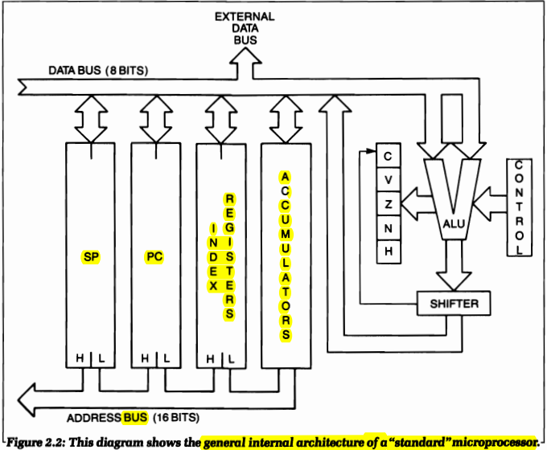

## The three buses

* The width of each bus differs from CPU to CPU, and from system to system.

### Address bus

* Communications between CPU and ROM, RAM, or I/O
* Up to 20 bits wide

### Data bus

* Actual information between the CPU and the enabled system block
* 16 bits

### Control bus

* Dual task of 1) electrically defining the type of communication, and 2) beginning and ending the transfer
* Width varies, but it has a nominal value of 5 bits

## ROM (read only memory)

* Stores the program of the system
* It’s content doesn’t disappear when the system is turned off
* In a process-control environment, nearly all programs reside in ROM

### Bootstrap

* Loads the program in ram

## RAM (random access memory)

* Volatile memory

## I/O (input/output)

* PIO: parallel input/output
* Interface chip

## ALU (Arithmetic-Logic Unit)

* Has shift and carry facilities

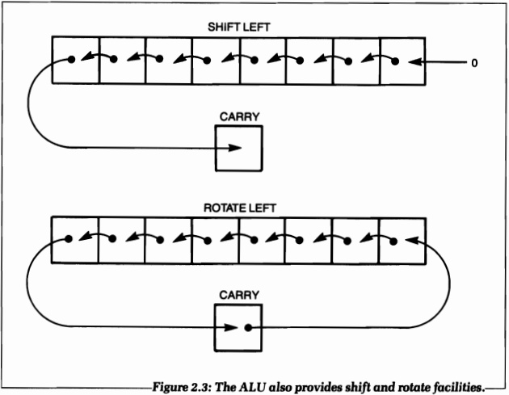

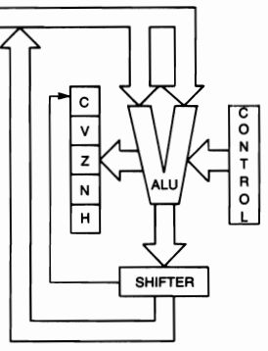

### Status or Condition Register

* Condition codes = condition flags

## Control Unit

* Synchronizes the sytem hardware and timing

## Accumulators (registers)

* Connected to the output of ALU
* Contain the results of arithmetic operations.

## Registers (Address Registers)

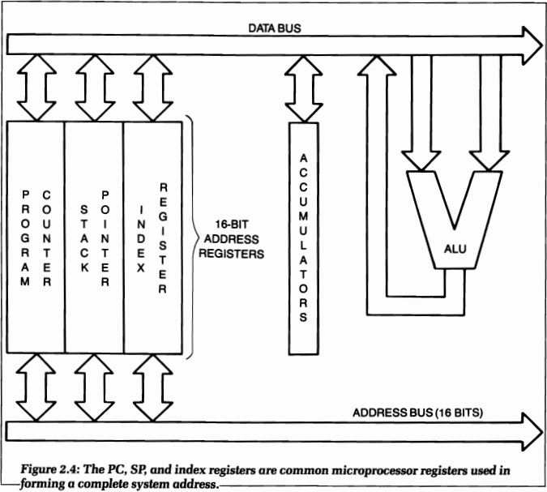

### The Program Counter (or PC)

* Contains the address of the next instruction to be executed

### The Stack Pointer (or SP)

* Implements the sytem stack
* Is used for handling interrupts and subroutinse, and for saving temporary data
* Contains the memory address of the top of the stack

### The Index Register

* Used to access blocks of data in the memory.
* Contains a displacement, which is automatically added to a base value when forming an address

### The Stack

* formally called a LIFO (last-in, first-out)
* stack is only accessible via two operations or instructions: PUSH and POP

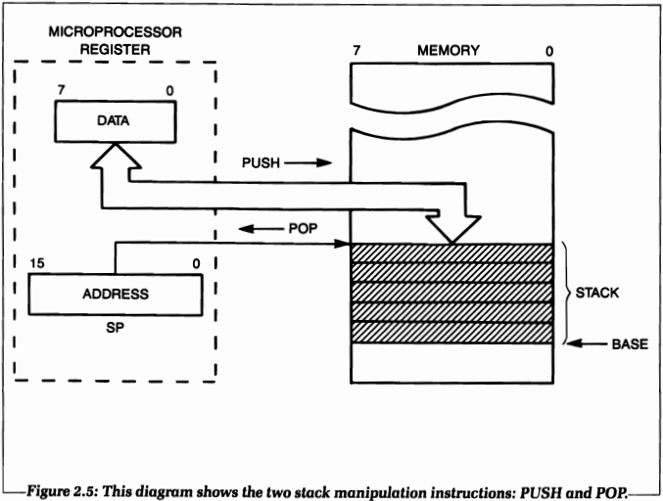

## The General Instruction Cycle

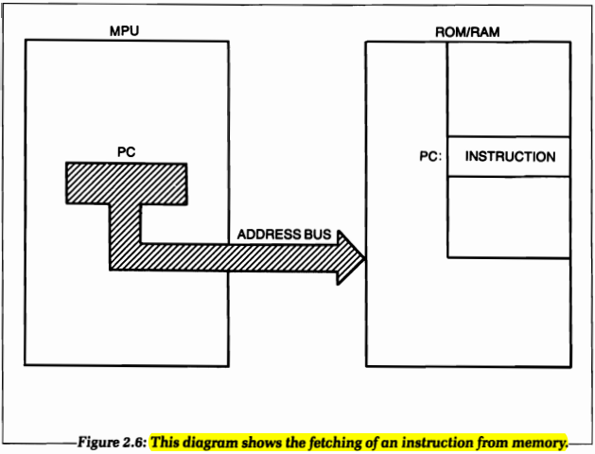

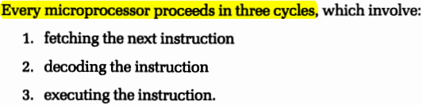

### Fetching

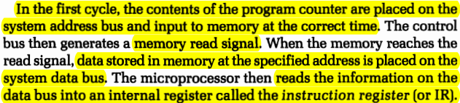

### Decoding and Executing

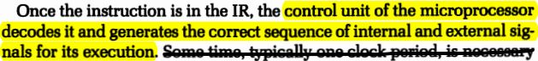

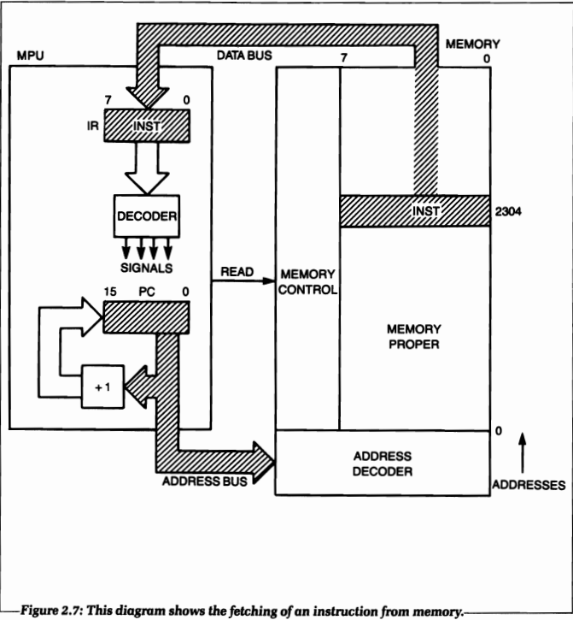

### Fetching the Next Instruction

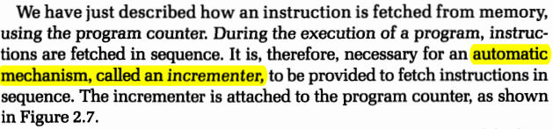

* Description is simplified. Some instructions are multiple bytes long, so it’s not that simple.

## Internal Organization of the 8086/8088

### BIU (bus interface unit)

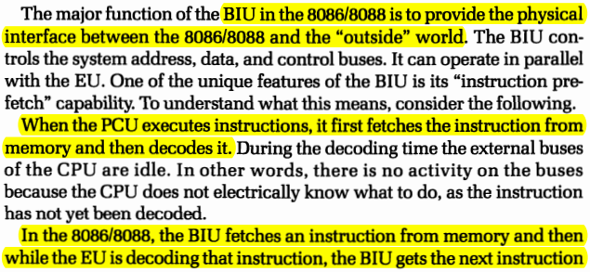

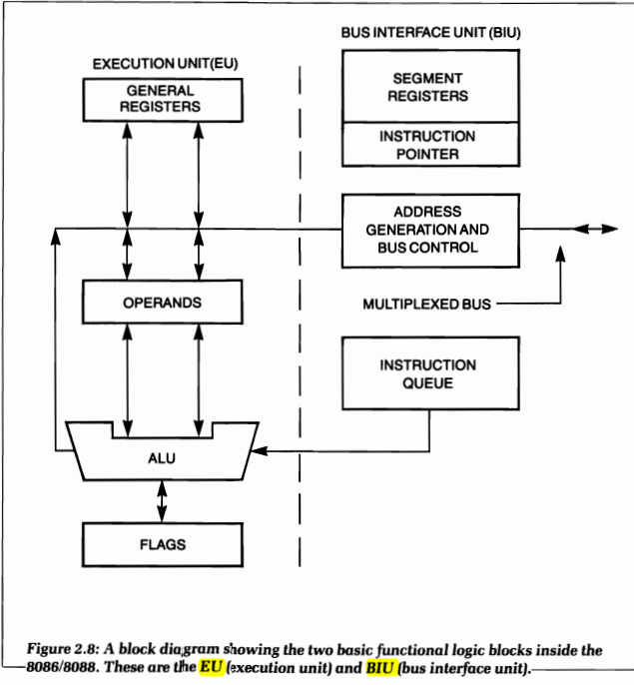

### EU (execution unit)

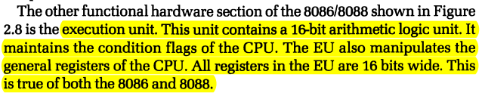

## General Registers

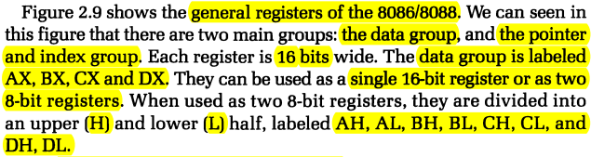

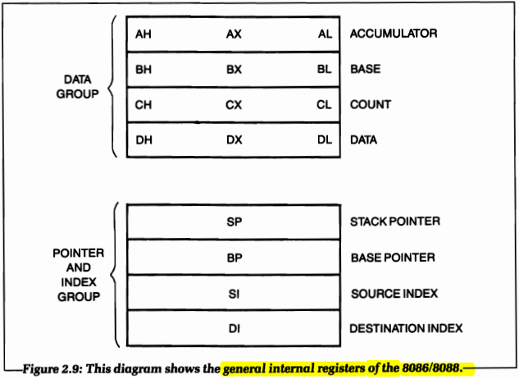

### Segment Registers

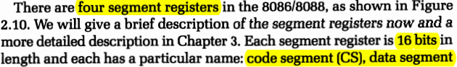

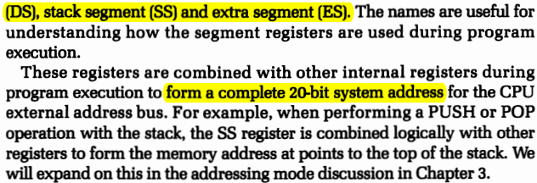

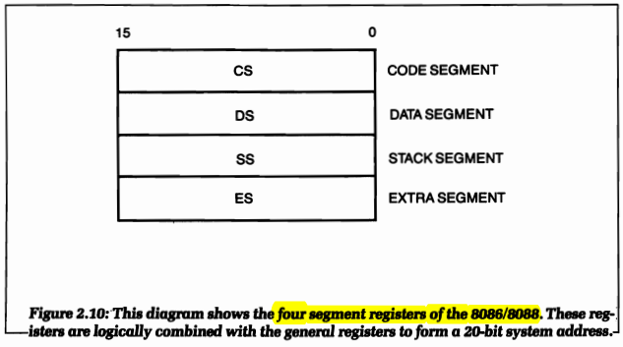

### Instruction Pointer

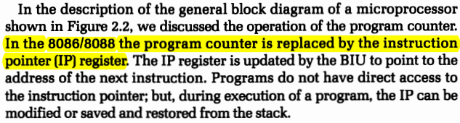

### Flags

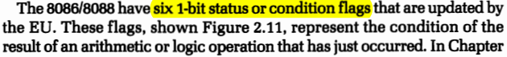



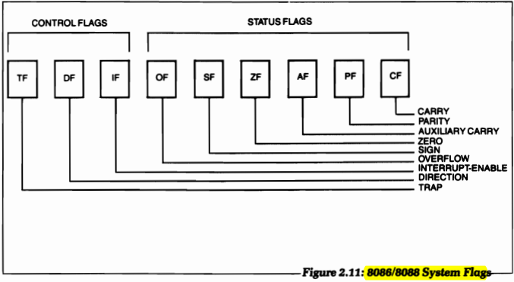

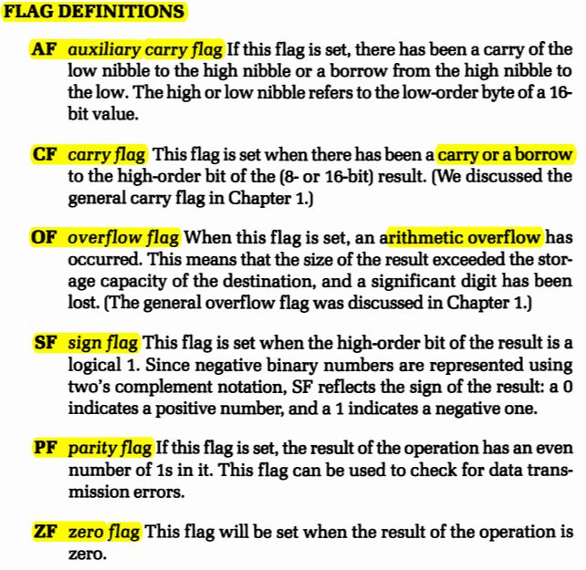

# 8086/8088 Memory Organization and Addressing Modes

## System Memory Organization of the 8086

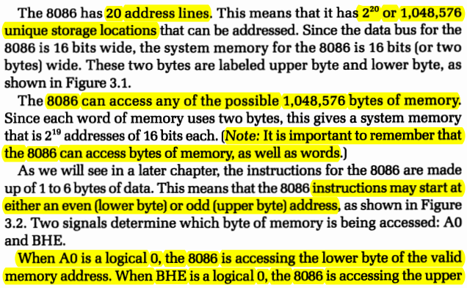

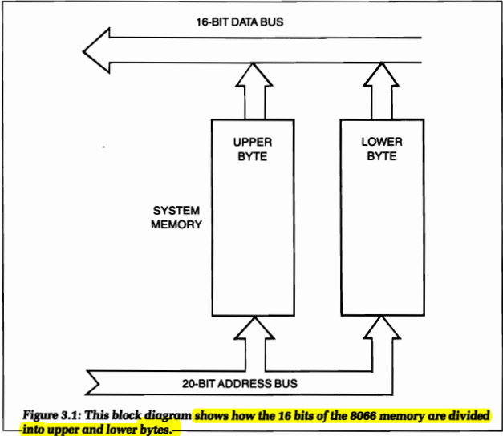

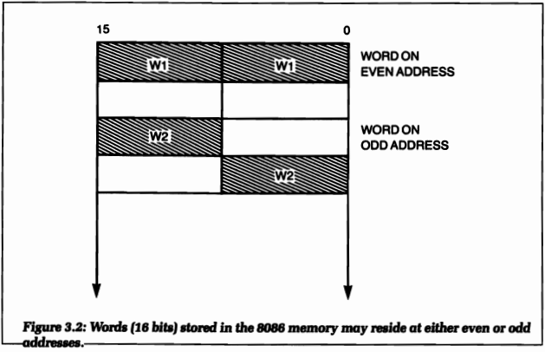

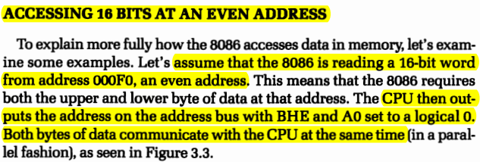

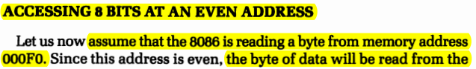



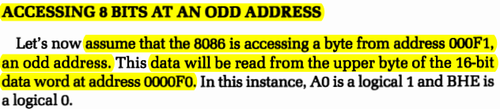

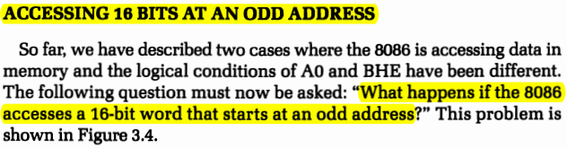

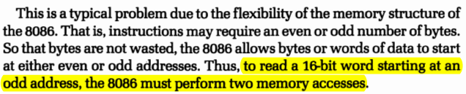

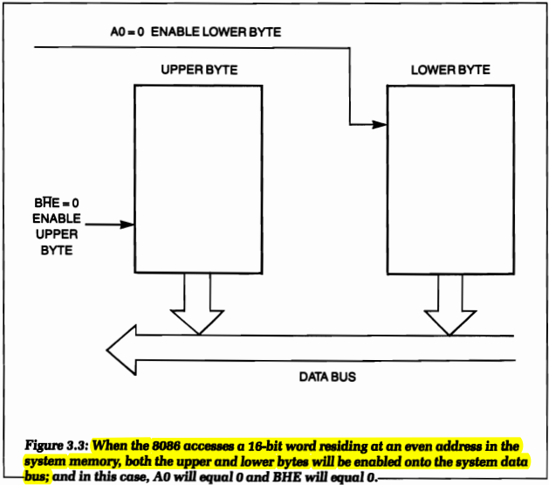

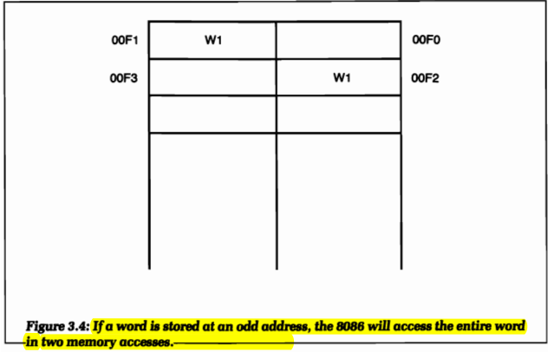

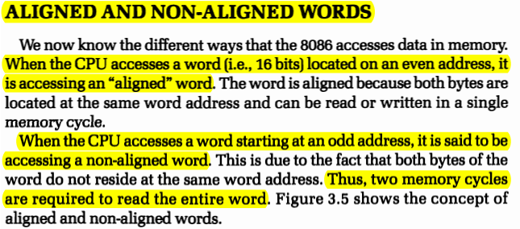

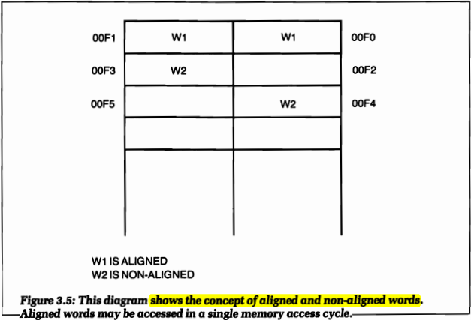

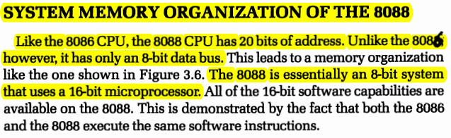

## Address generation with the 8086/8088

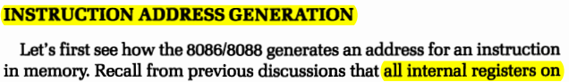

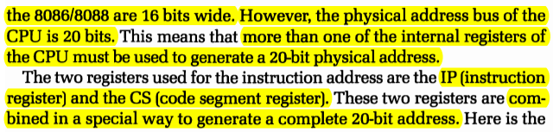

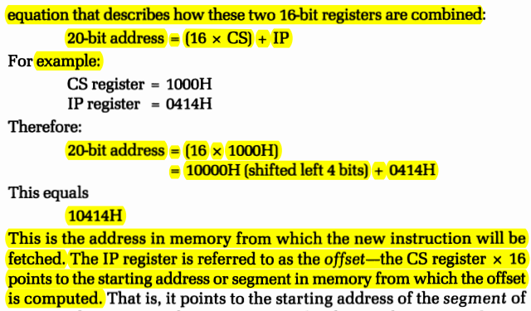

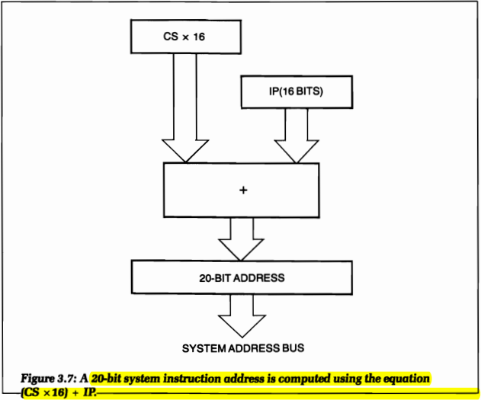

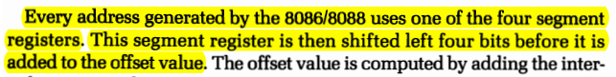

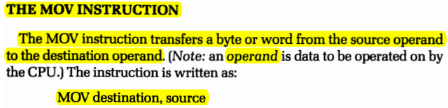

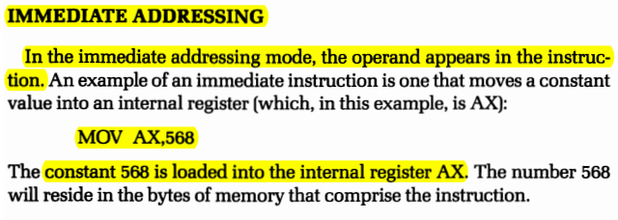

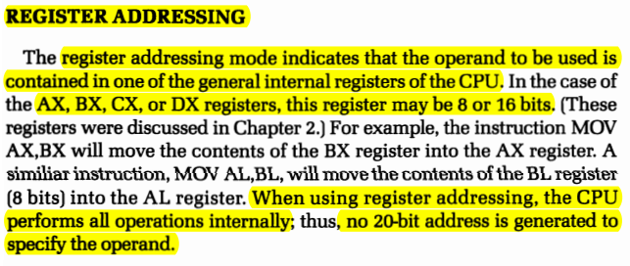

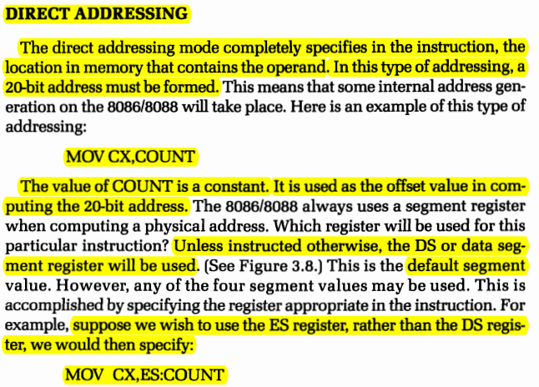

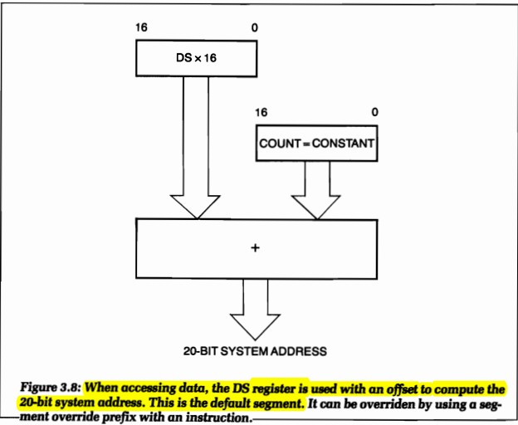

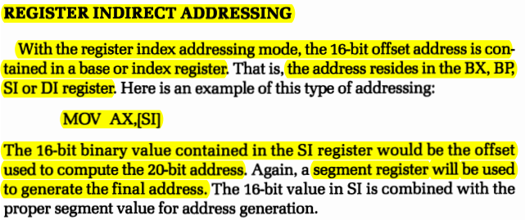

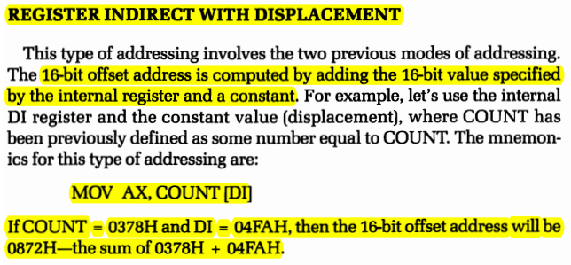

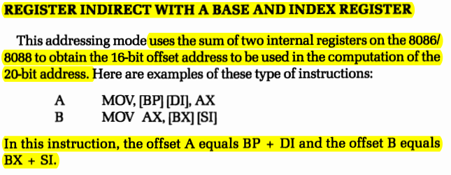

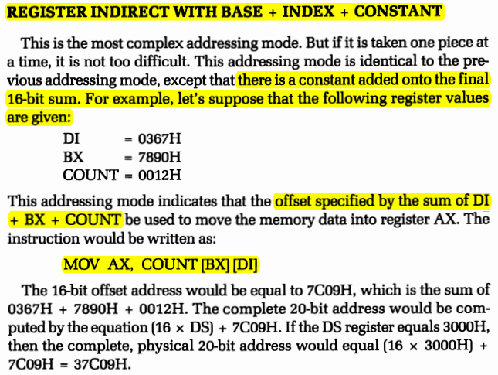

## 8086/8088 Object Code

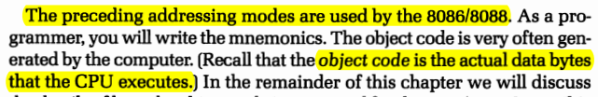

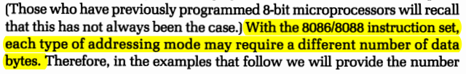

### Reg Field and W Bit

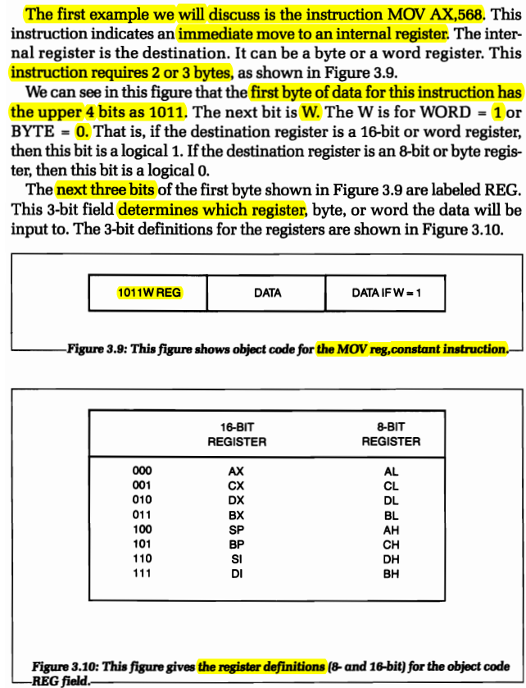

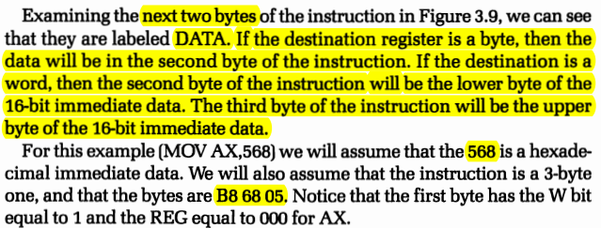

### D BIT, MOD, AND R/M

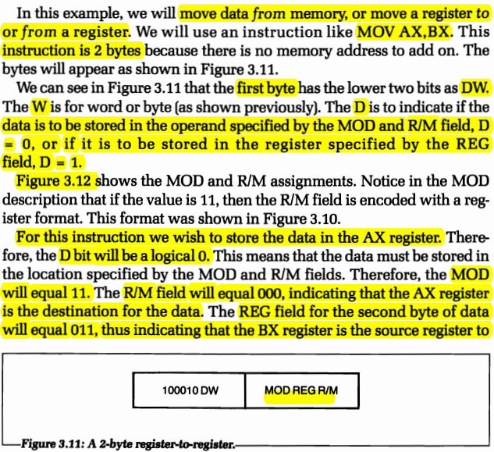

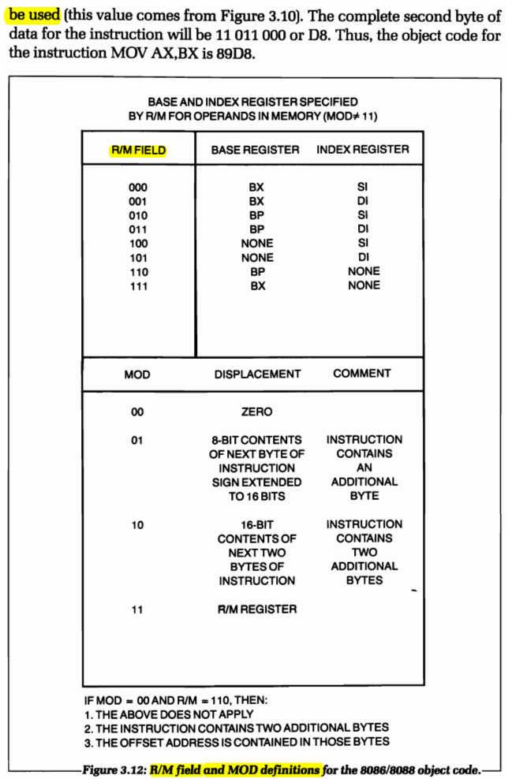

## Object Code for Indexing and Base Register use

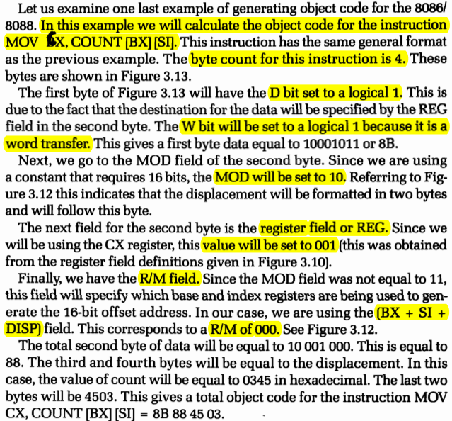

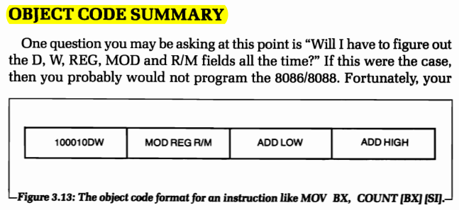

# Basic Programming Techniques

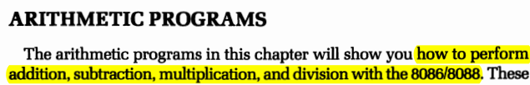

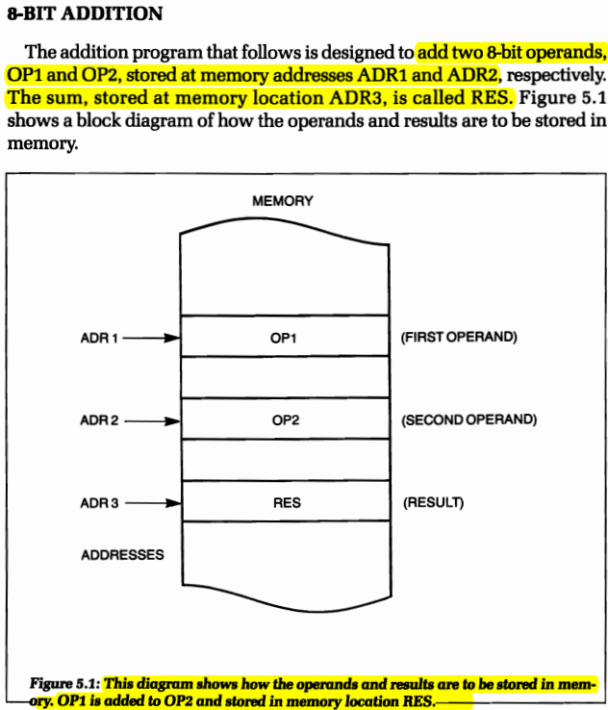

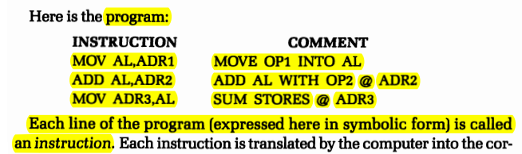

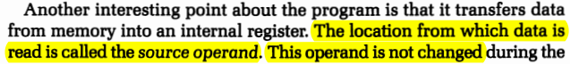

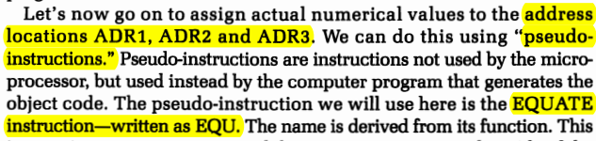

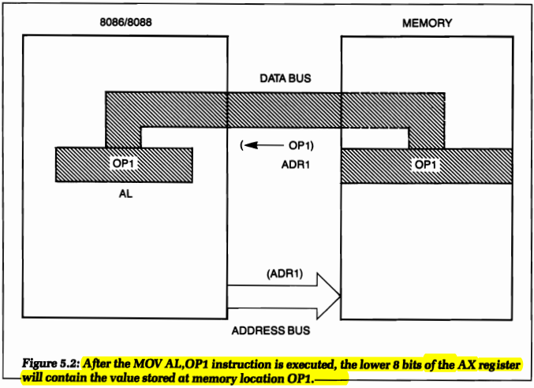

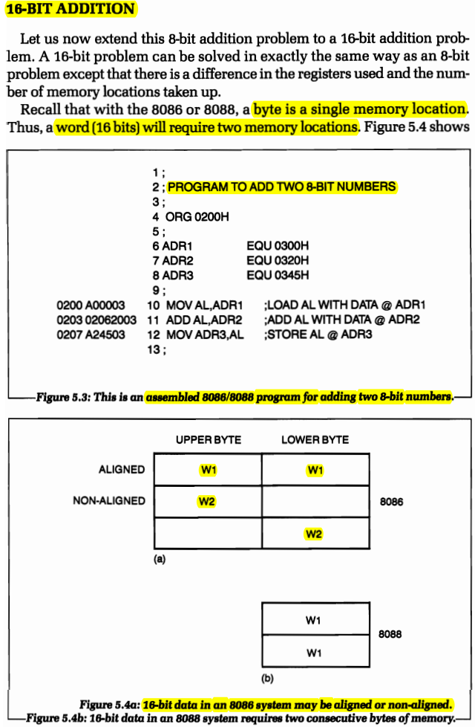



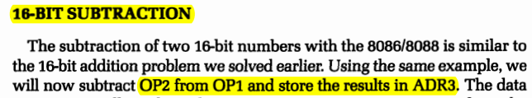

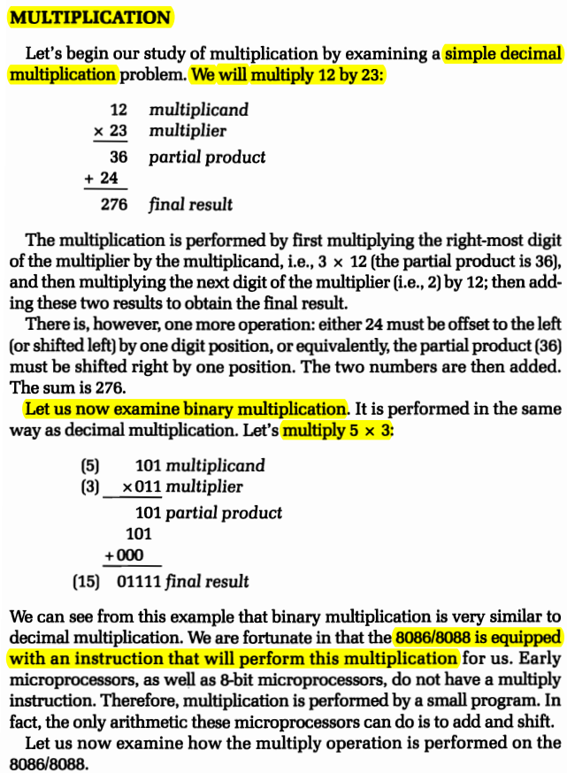

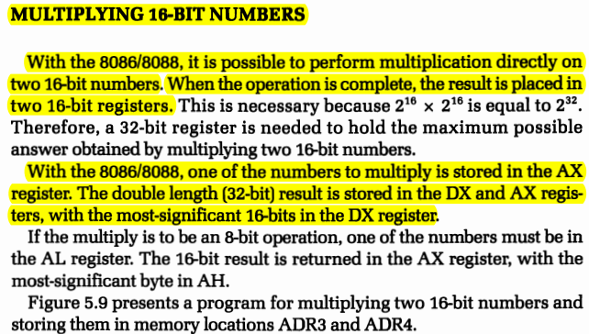



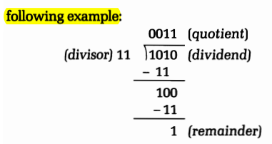

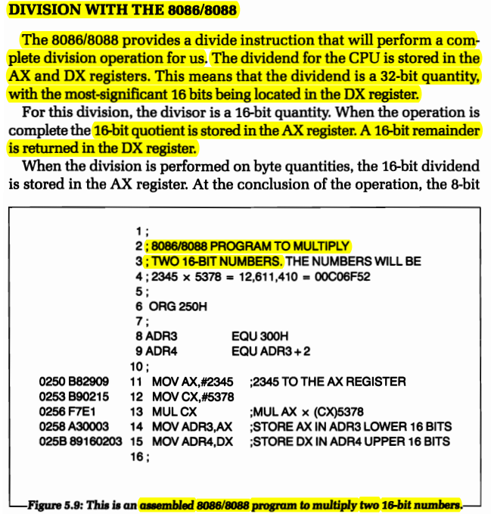

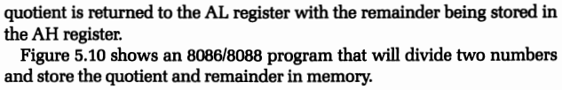

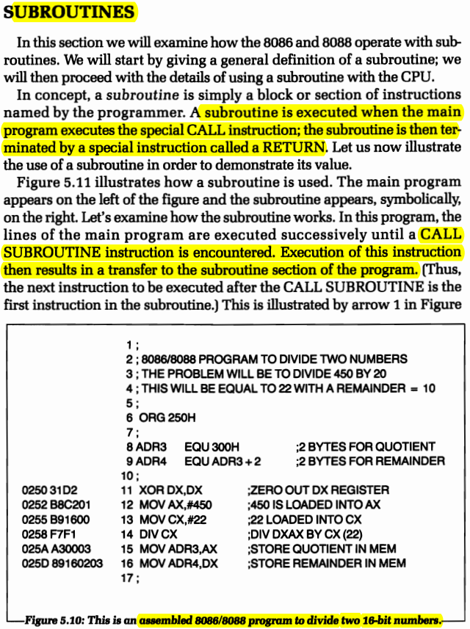

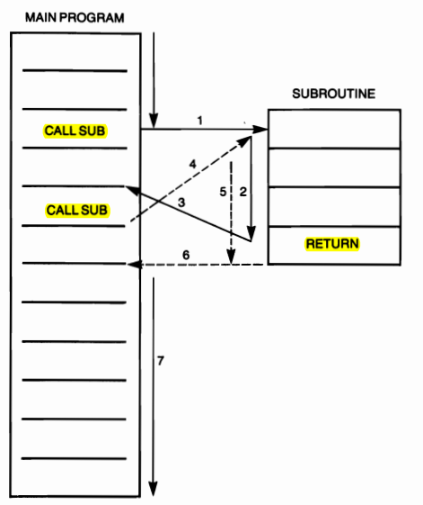



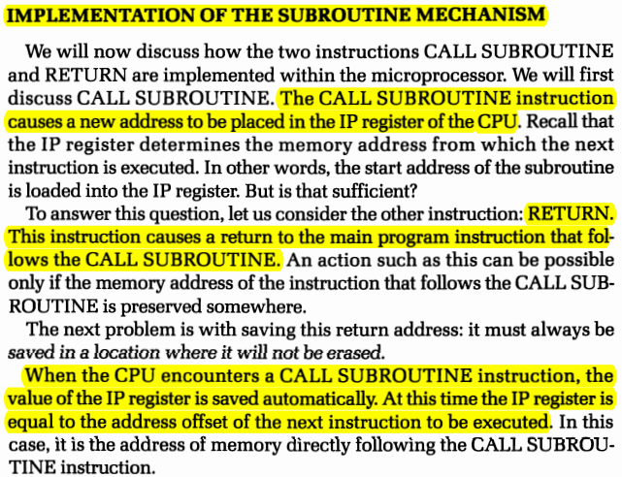

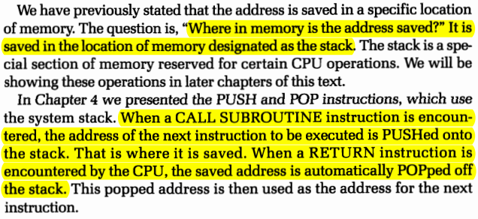

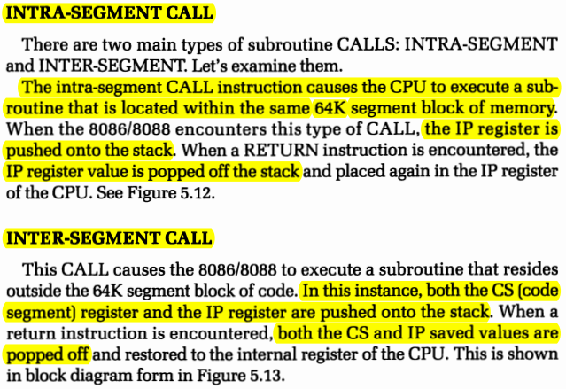

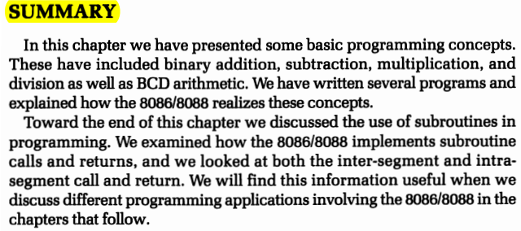

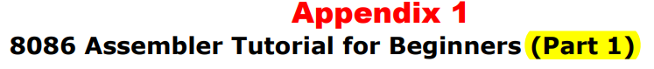

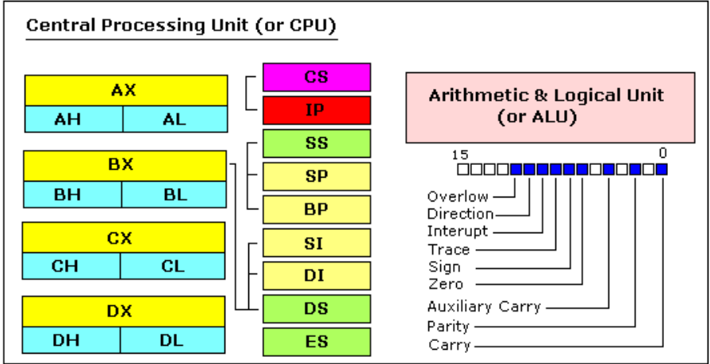

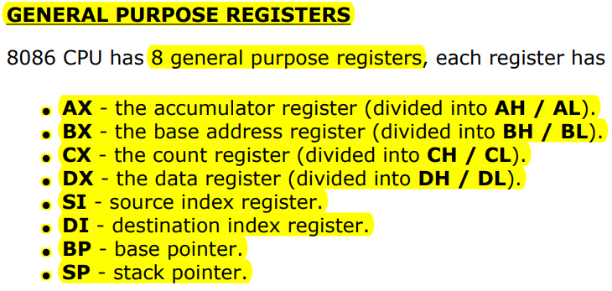

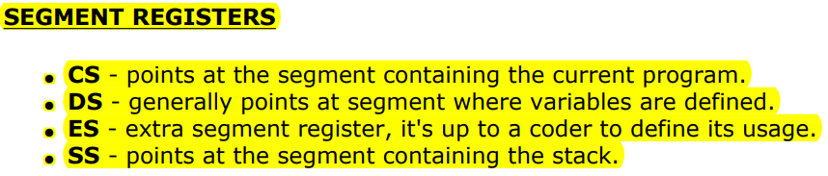

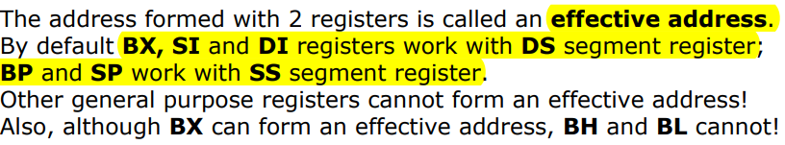

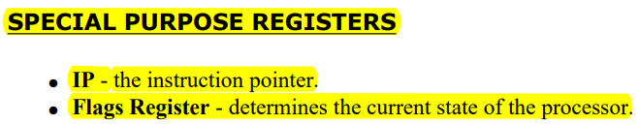

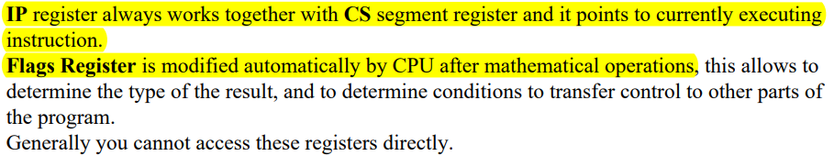

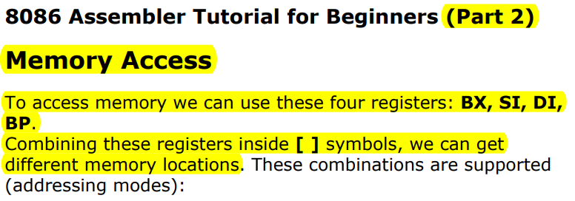

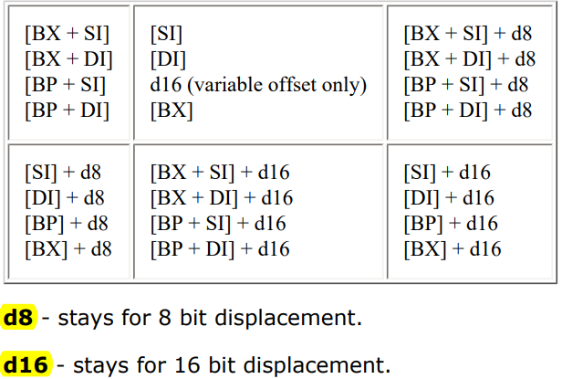

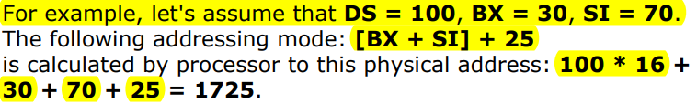

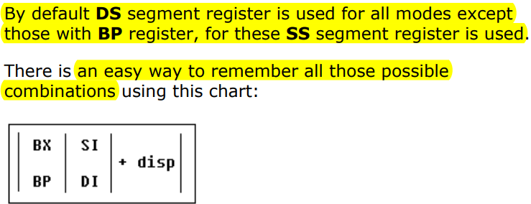

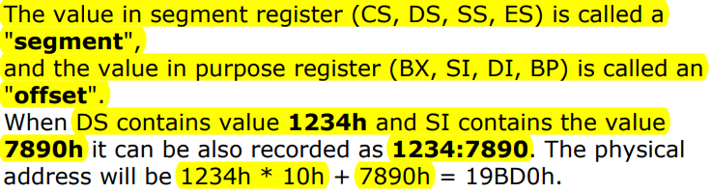

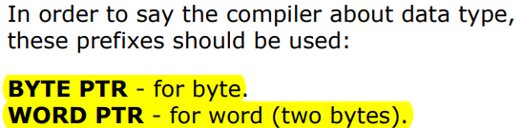

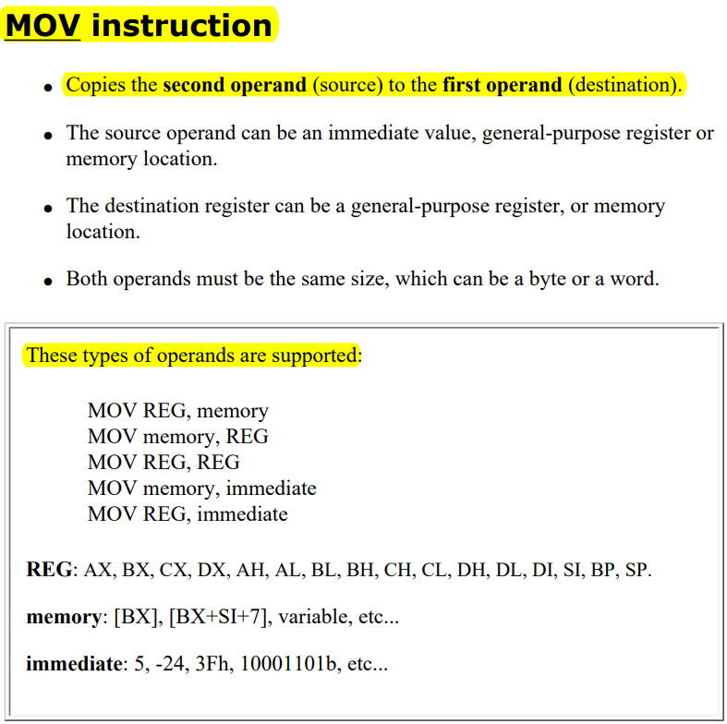

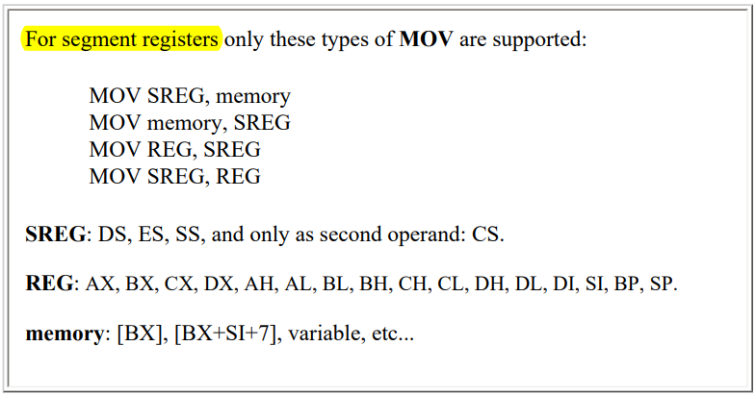



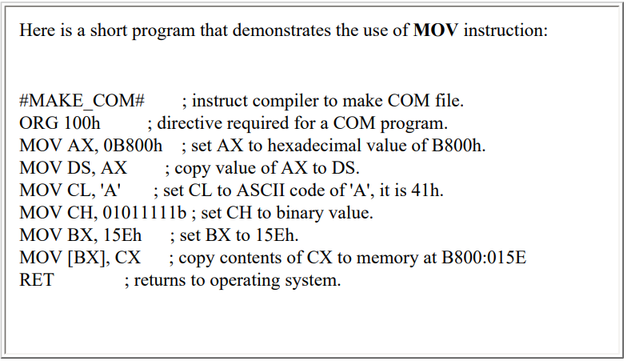





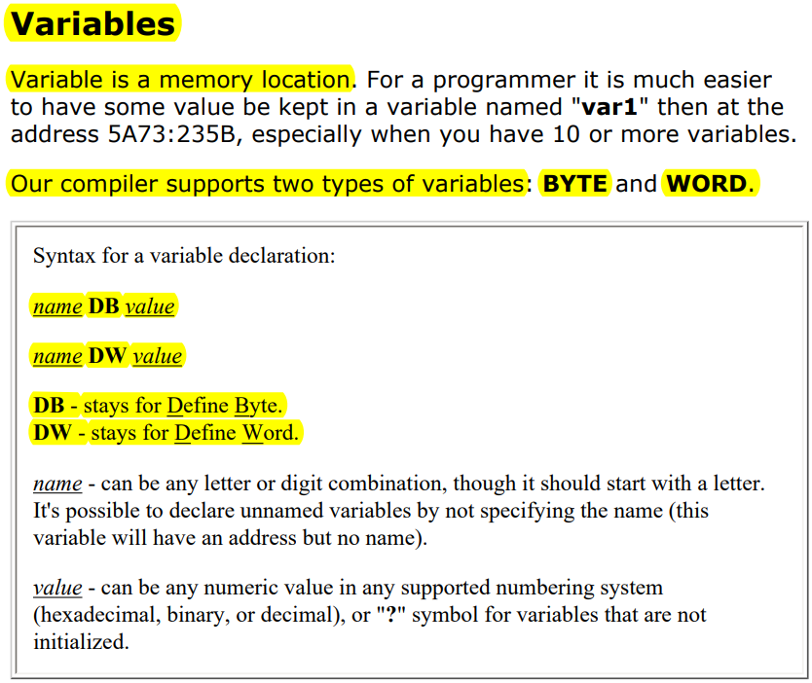



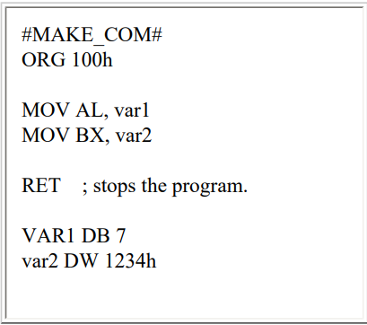

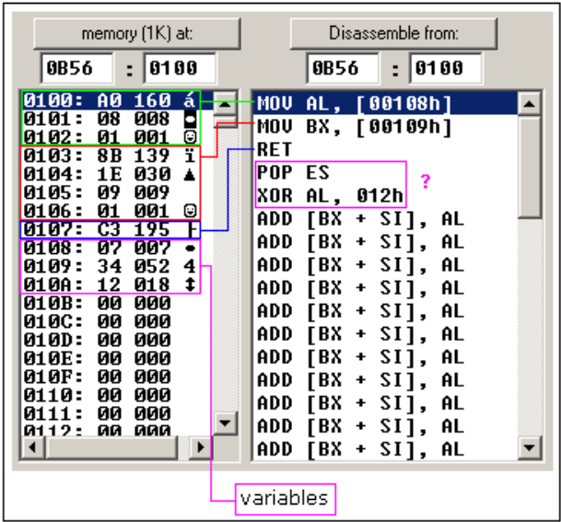

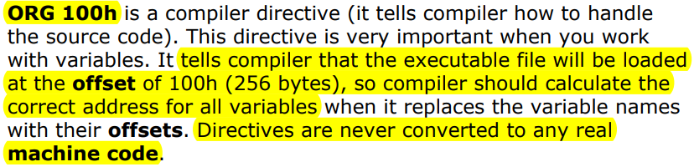

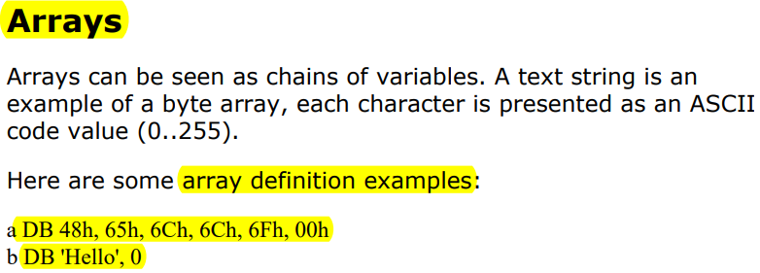

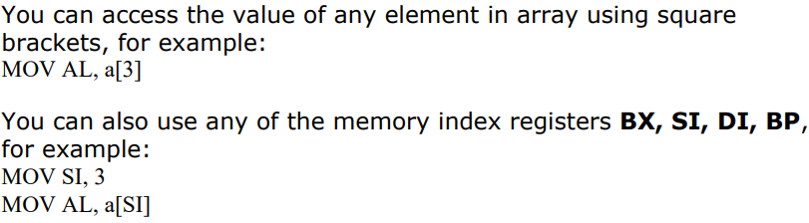

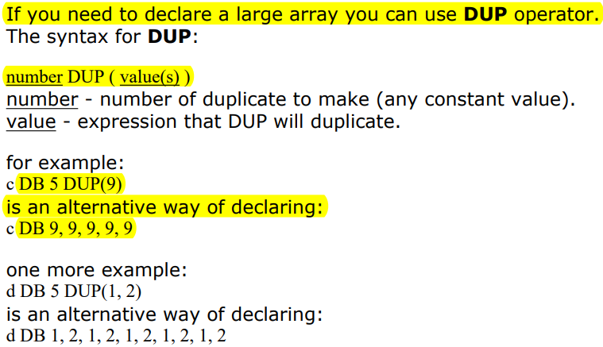

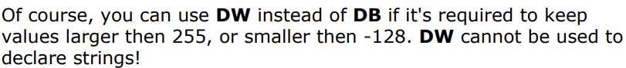

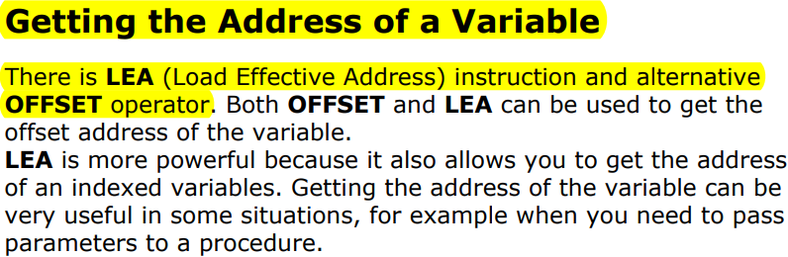

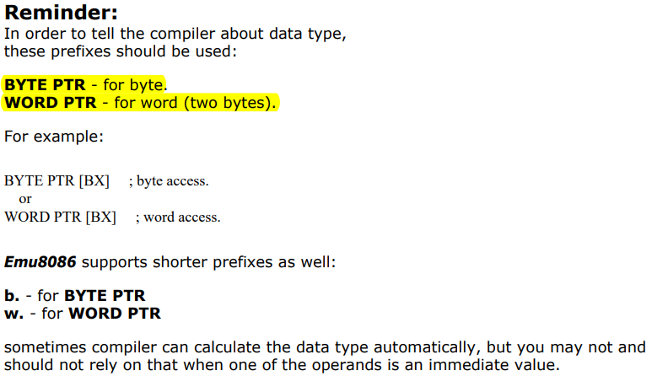

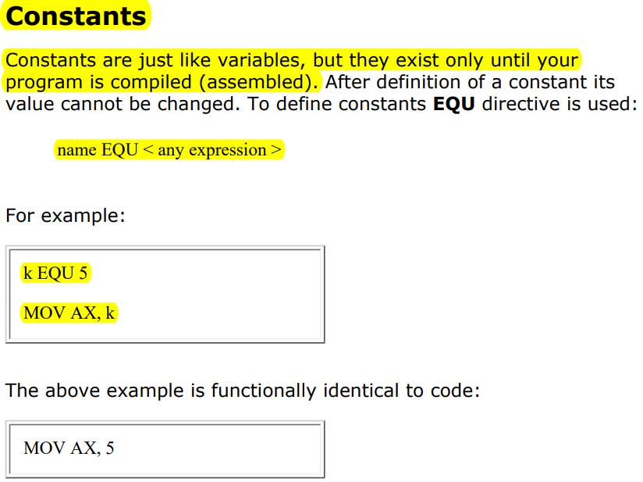

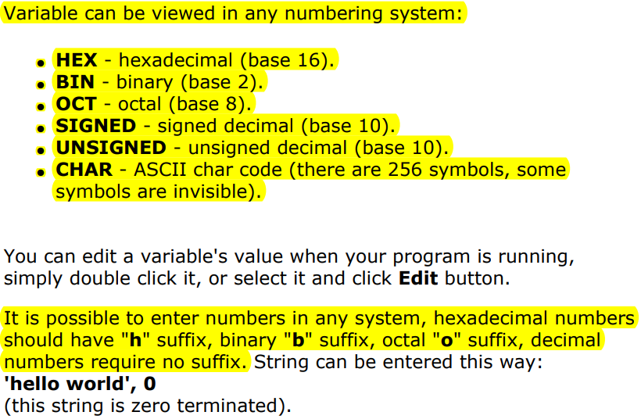

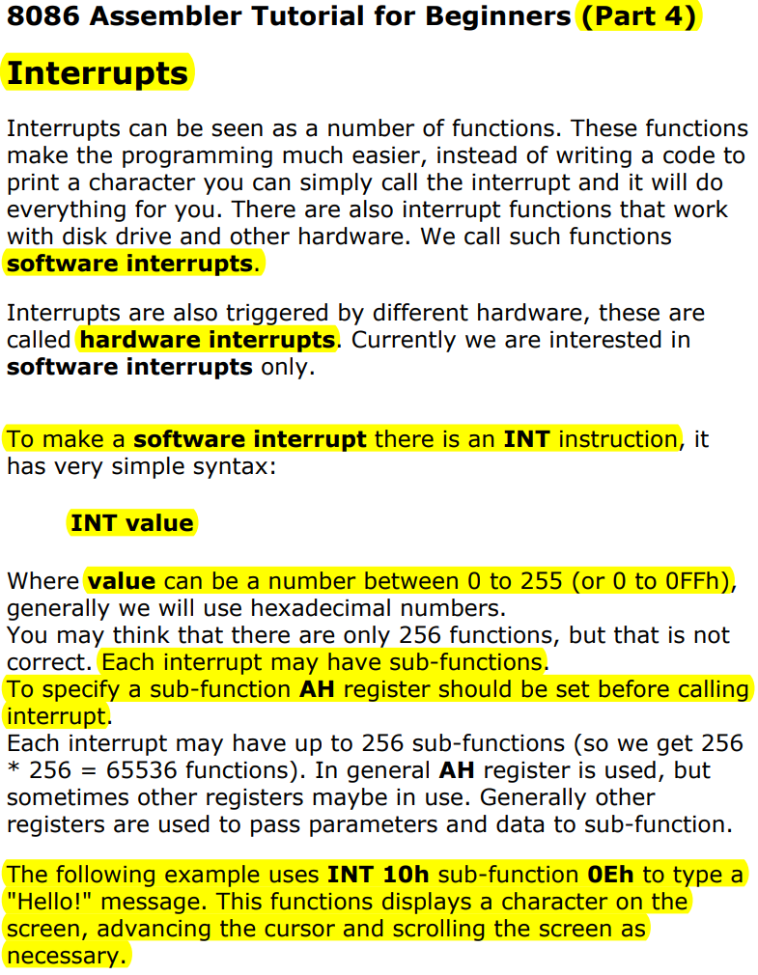

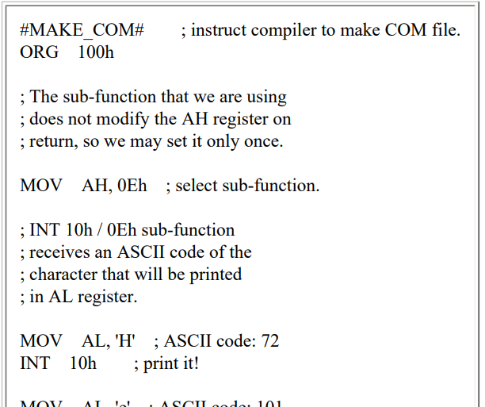

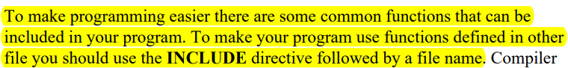

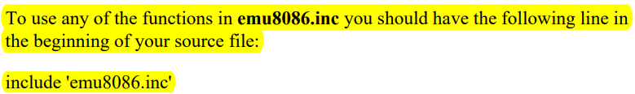

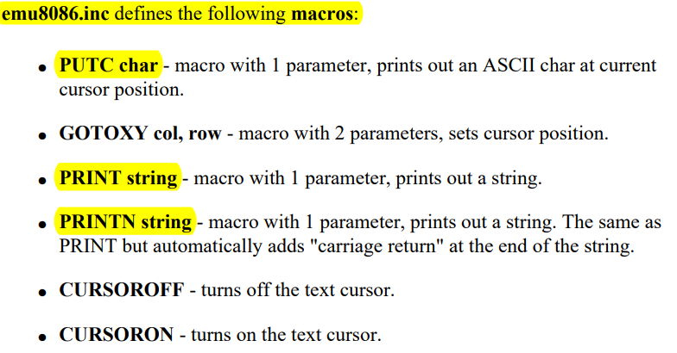

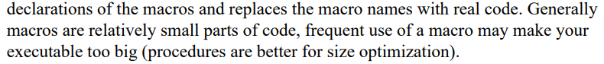



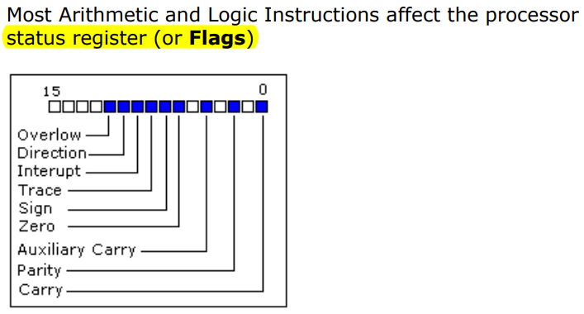

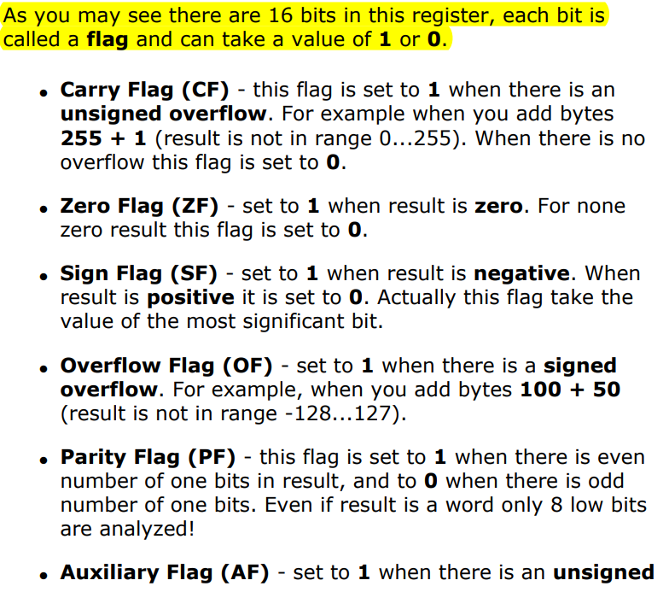

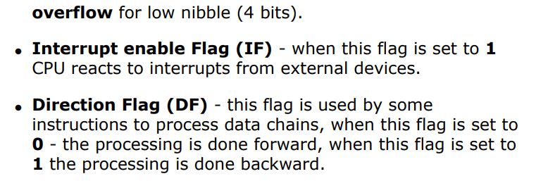

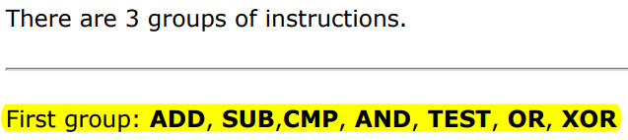



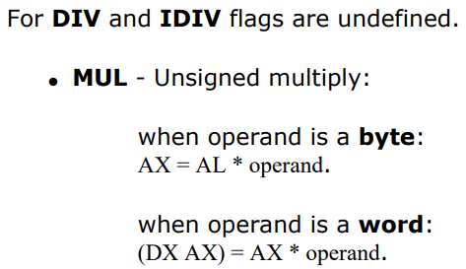





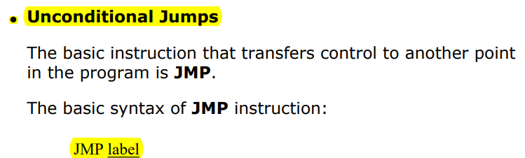



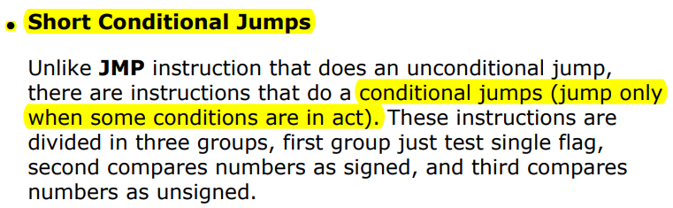

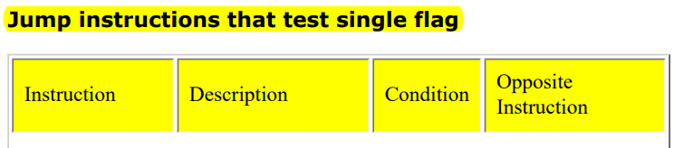

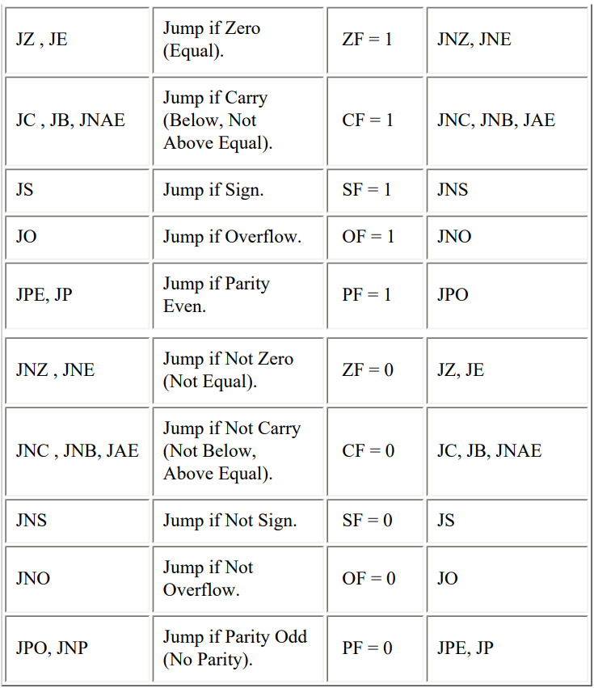





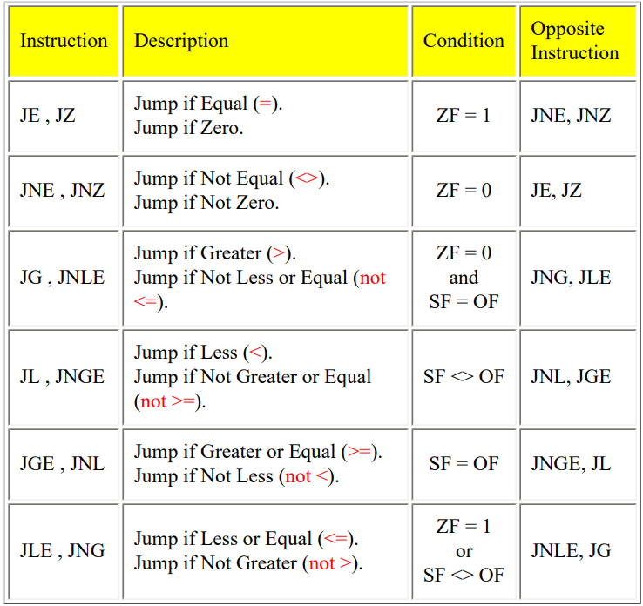





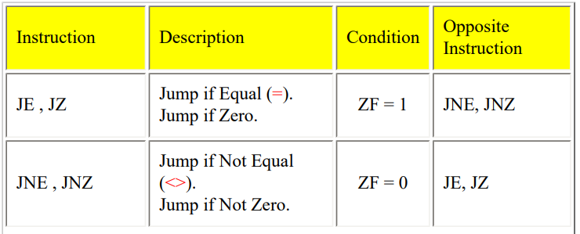

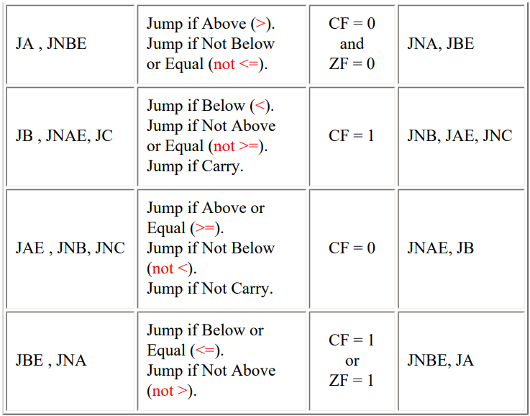

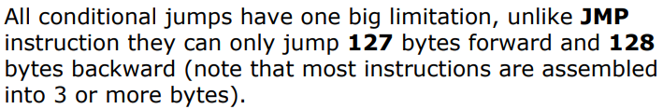



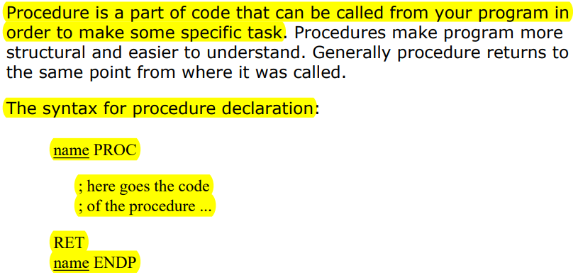



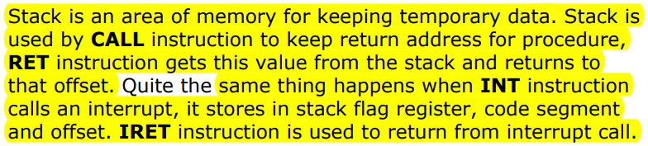

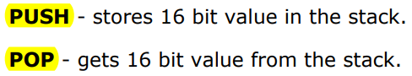

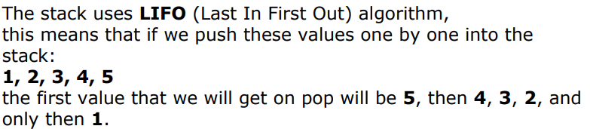

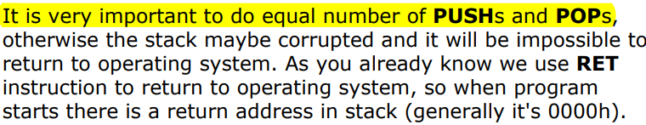





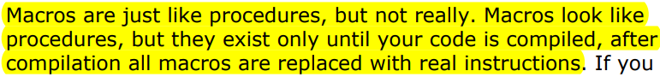

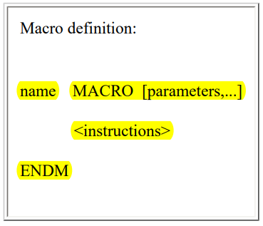



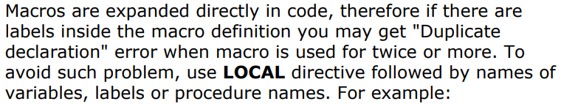

# 8086 System Design

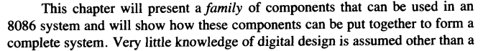

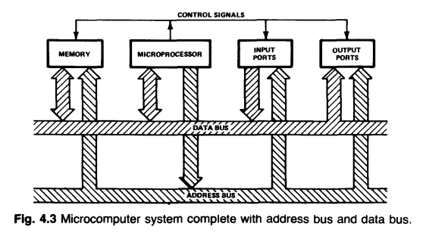

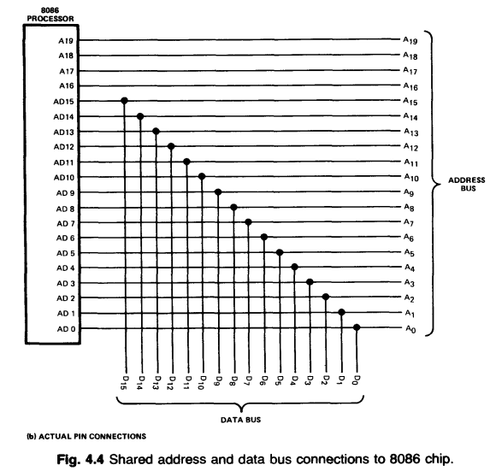

### Address Latching (salpa)

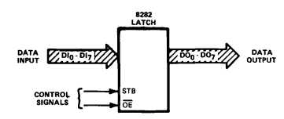

* The latch stores the address, so it doesn’t get lost when data is transferred

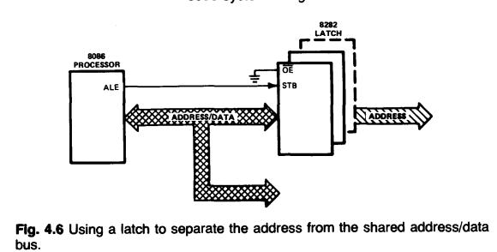

* 3 latches are used (8 bits each) to store 20 bit address, but the last one can be emitted on some configurations, where the memory is limited.
* ALE: address-latch-enable

### Data Amplifying

* “An amplifier that is able to transmit and receive in either direction is called a transceiver”
* “oomph” = power

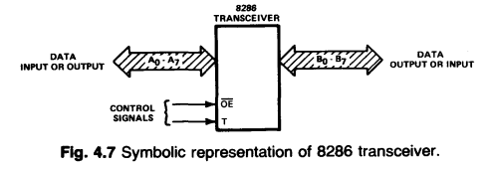

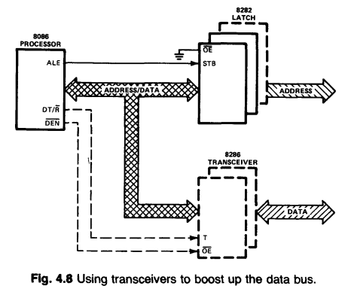

* (transceivers are not necessary in small systems.)

### Measuring Time

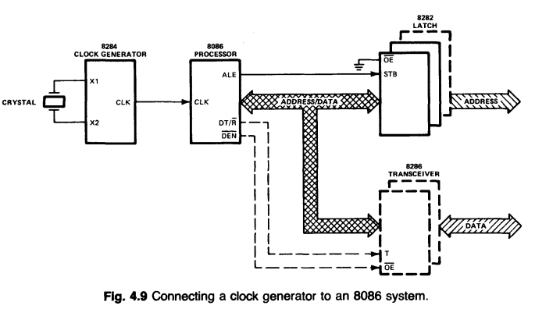

* Clock generator is used for example to delay some actions so that the system is stable to function (waiting that the bus is stable before sending a command to use that bus data)

### Memory Units

* RAM (Random access memory) is really RWM (Read write memory), but it was too similar to ROM (Read only memory) (roms vs rwms)

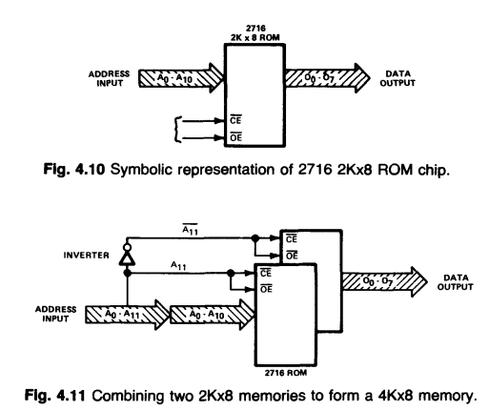

* Address decoding: Selection process that determines which chip is used

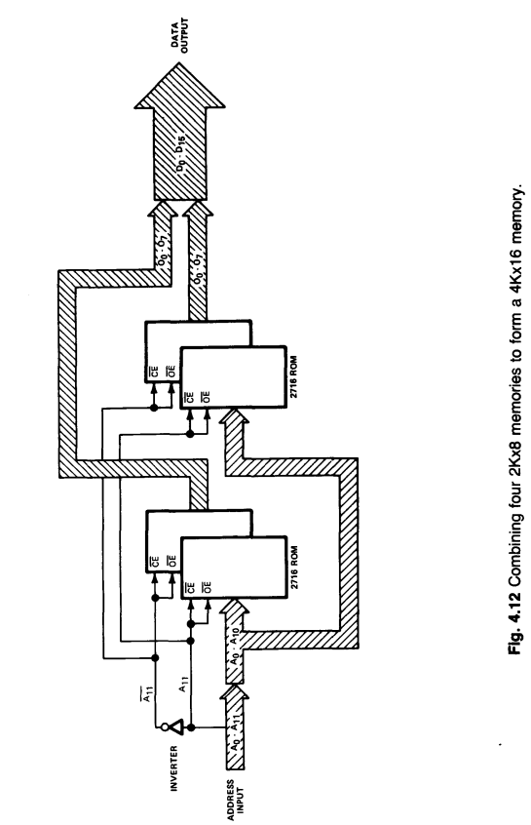

* BHE(bus high enable): tells the memory if it should excecute a byte or word move. BHE information is stored with the address to the latch
* BHE is not needed when information is read from the memory. Only when it is written

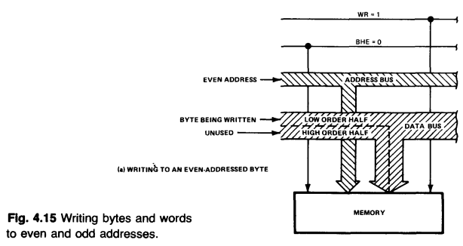

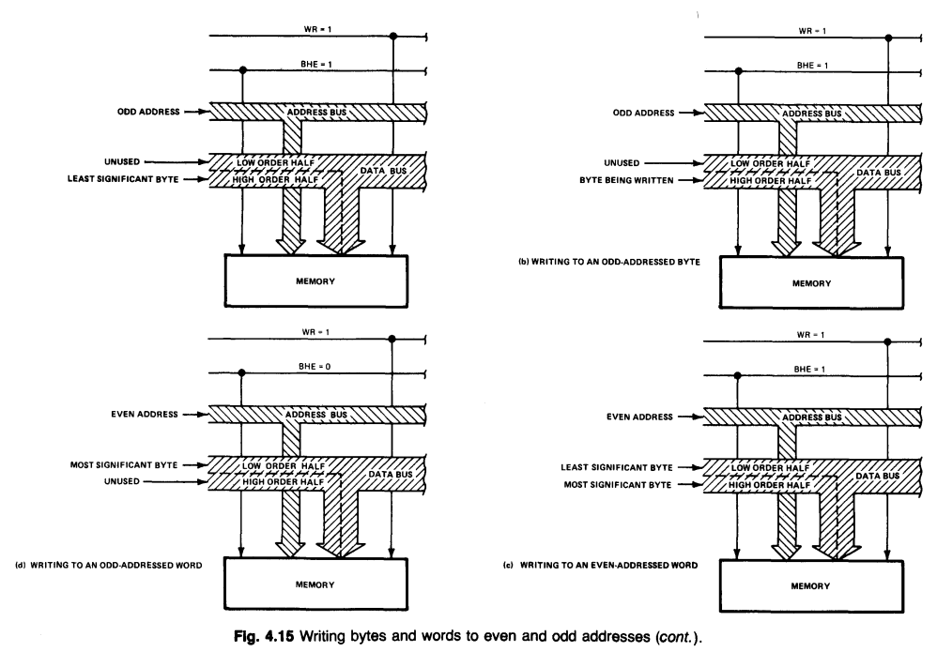

### Input/Output Ports

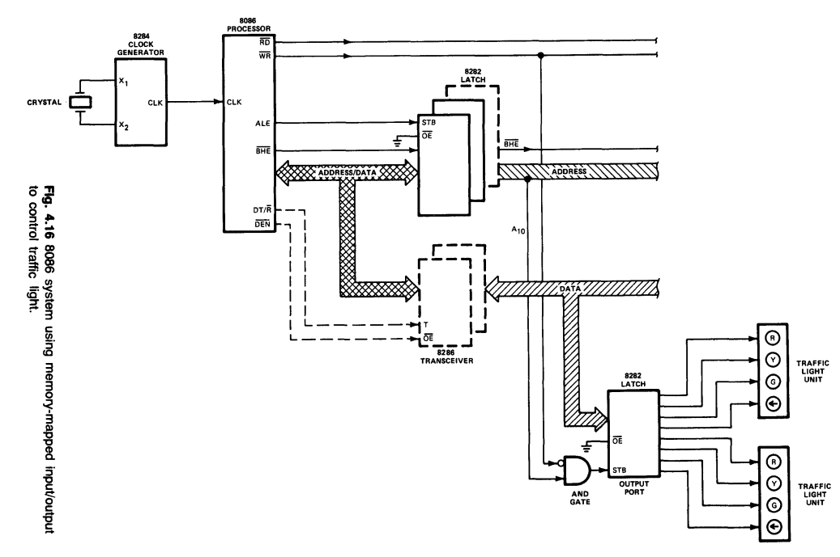

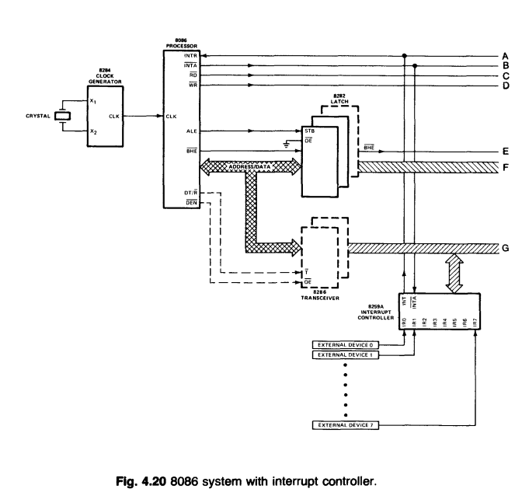

### Interrupt Servicing

* INTR: normal interrupt by external device
* NMI: non-maskable interrupt = give me a hand now because later will be too late
* INTA: interrup acknowledge
* interrupt controller: to control multiple devices

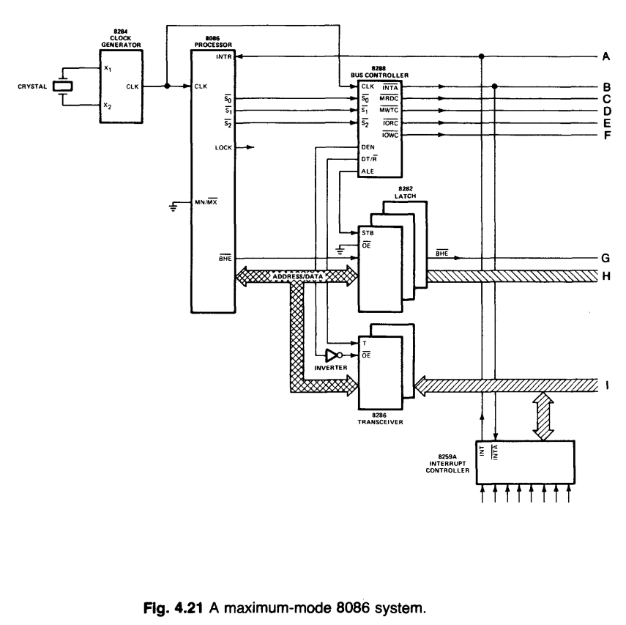

## Interrupts for the 8086/8088

How CPU handles NMI request:

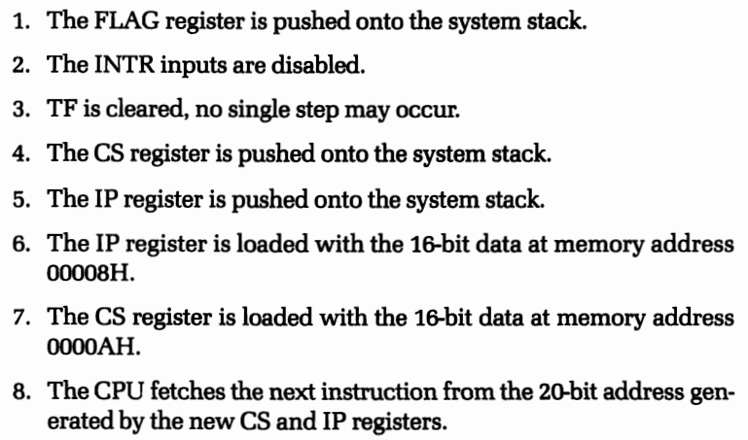

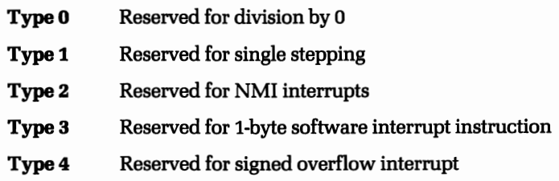

* There can also be internal interrupts that are created by software and not external devices
* CPU loads the information back that it stored when starting an interruption. It will then continue from where it left off.
* CPU reset

## Input and Output for the 8086/8088

* Microprocessors that use memory space for 1/0 are said to use "memory-mapped I/O

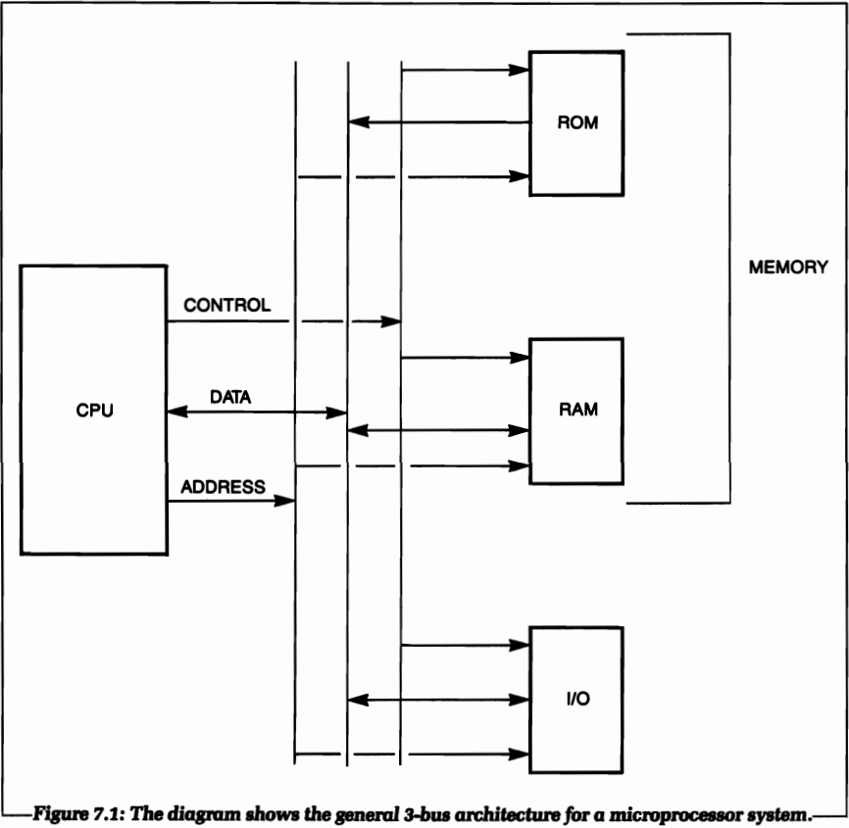

* The 8086 and 8088 do not use memory-mapped 110. Thus, all the system memory space can be used for memory, as the system I/O has its own address space. An 110 architecture like this is called "I/O-mapped 110."

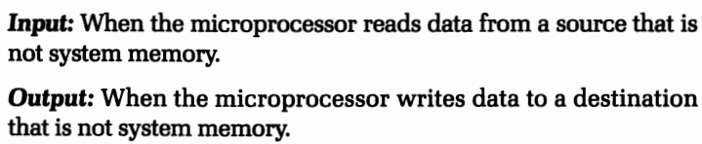

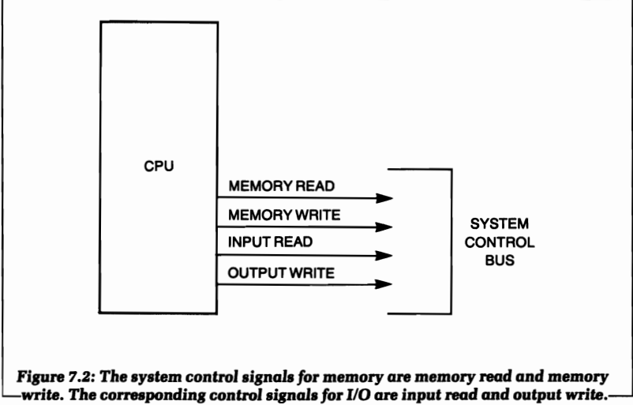

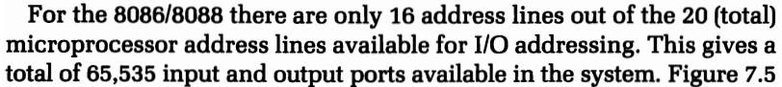

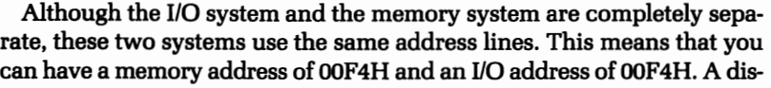

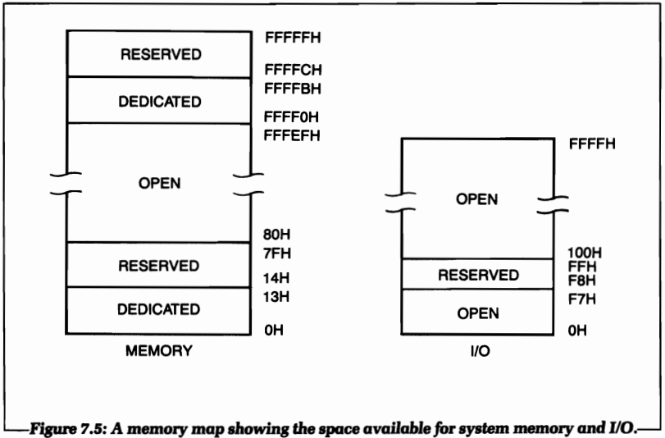

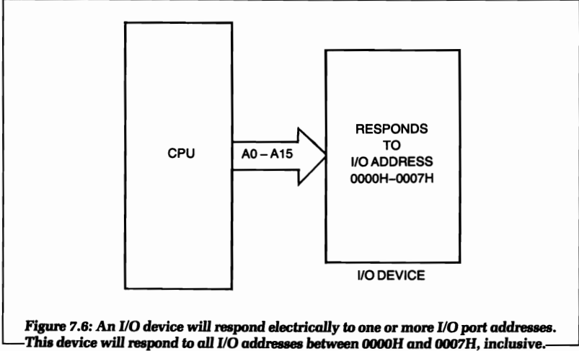

* Fixed port addressing (I think at least): using a manual port address (only 8bits?)
* Variable port addressing: using a variable as the address (leads to DX) (16 bits addressing)

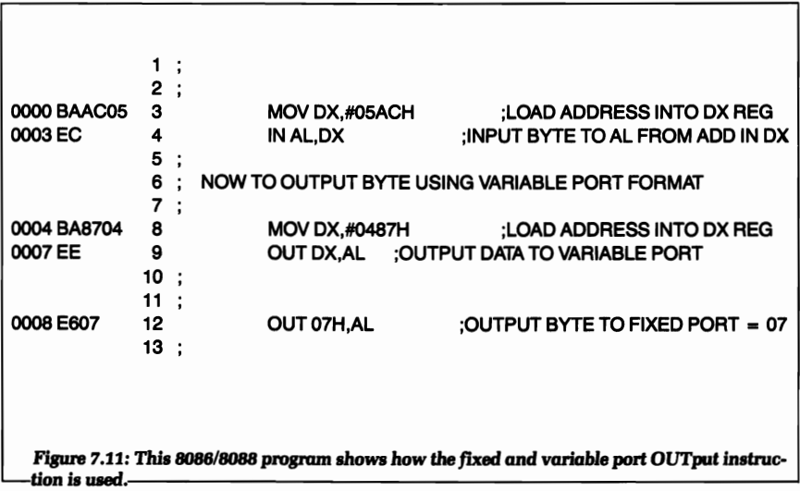

### Generating a signal with software

### Generating a pulse

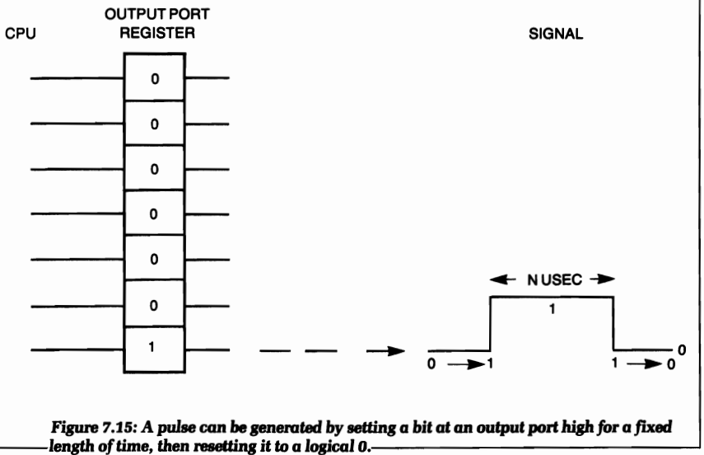

### Generating a software delay

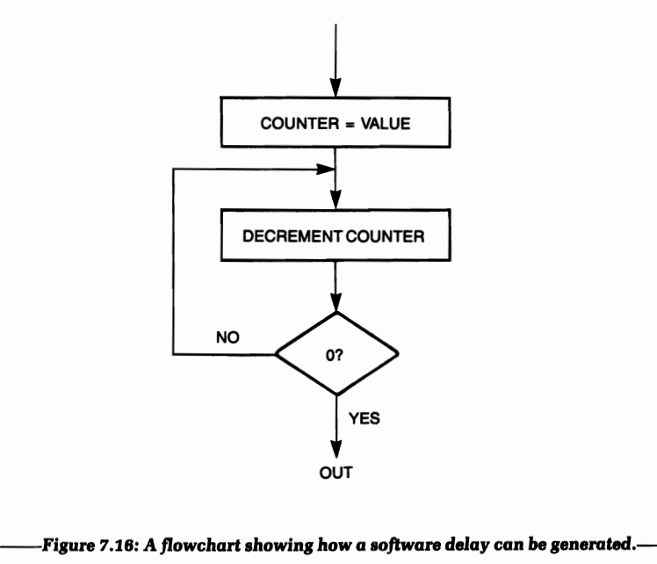

### Using 2 registers for longer delay:

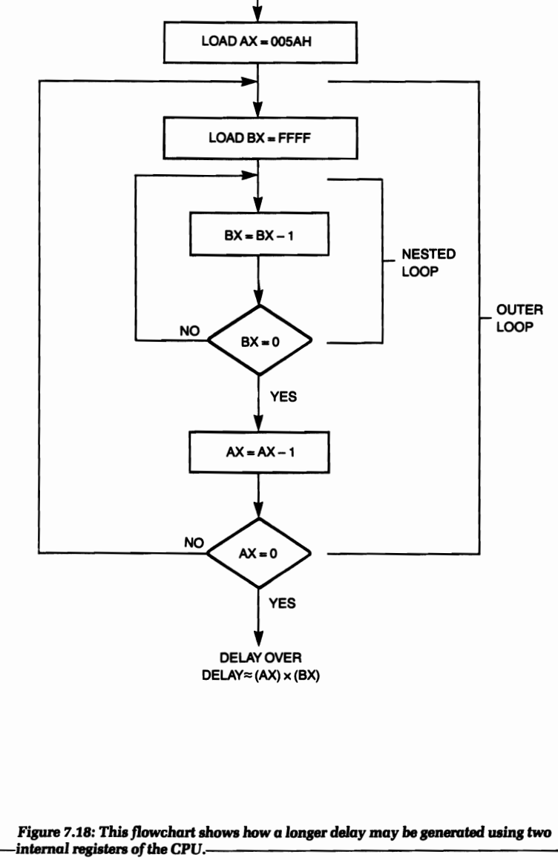

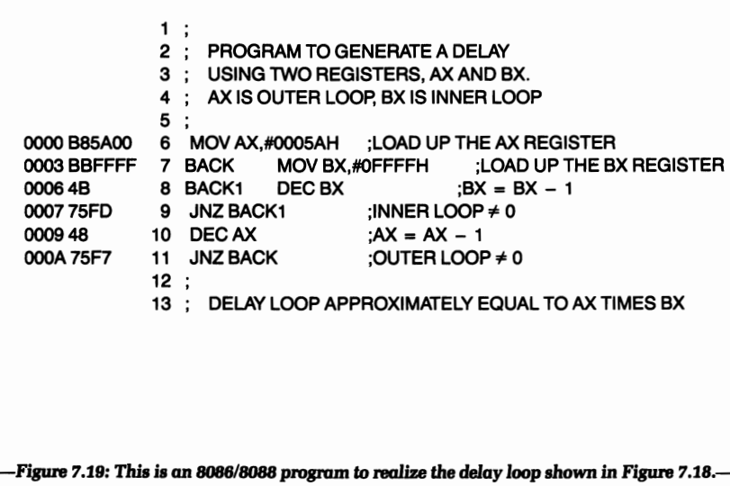

### Physical connection to the cpu system

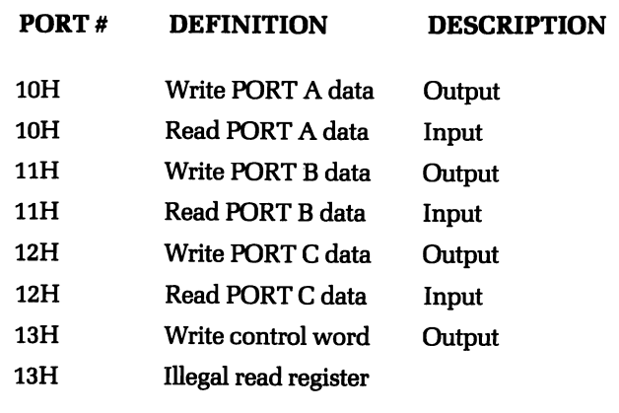

* 10H,… addresses are sent by A0 and A1.
* The control byte is stored (probably) in 8255 internal register, before processor can use it

### Example of keyboard scanning

### Programming the 8253 Timer Chip

# 8 More Applications using the IBM personal computer

## BIOS

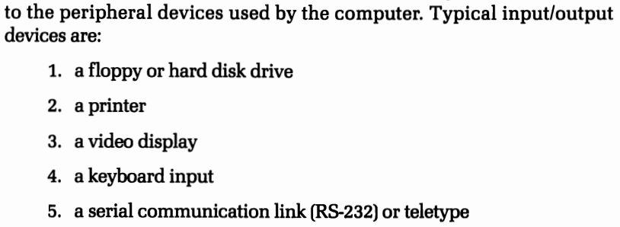

## Printer example

## Keyboard example

# 9 Program development

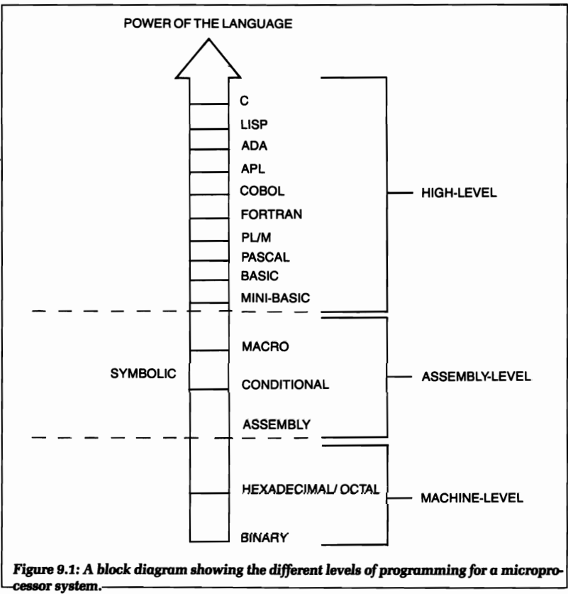

## Assembly

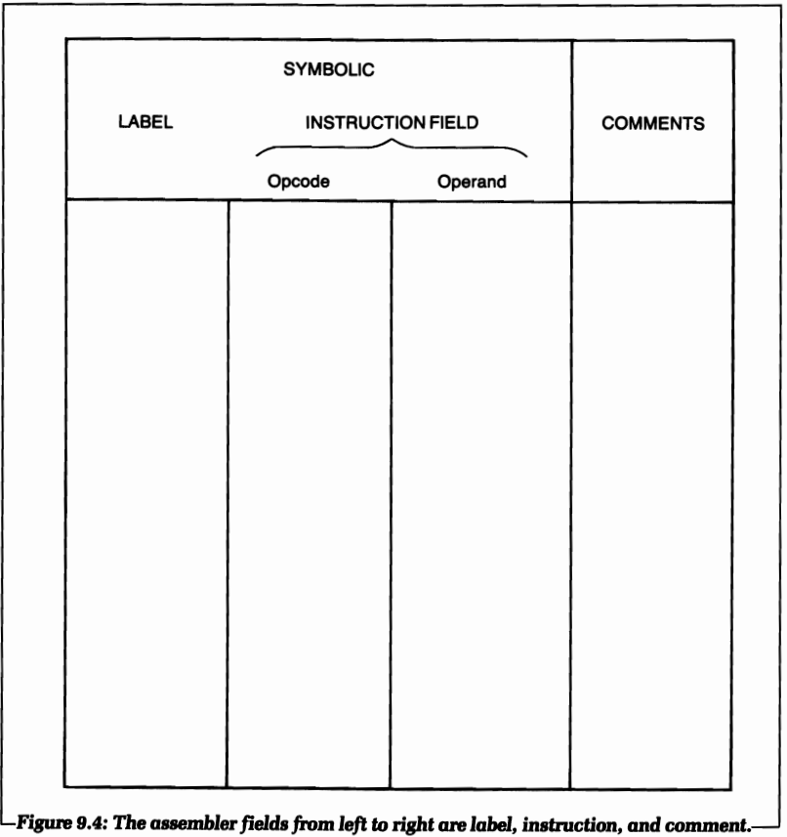

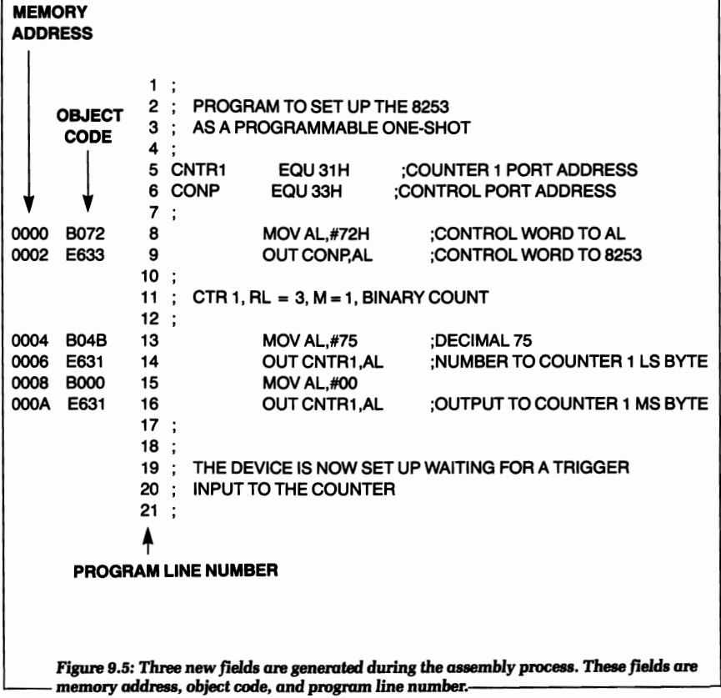

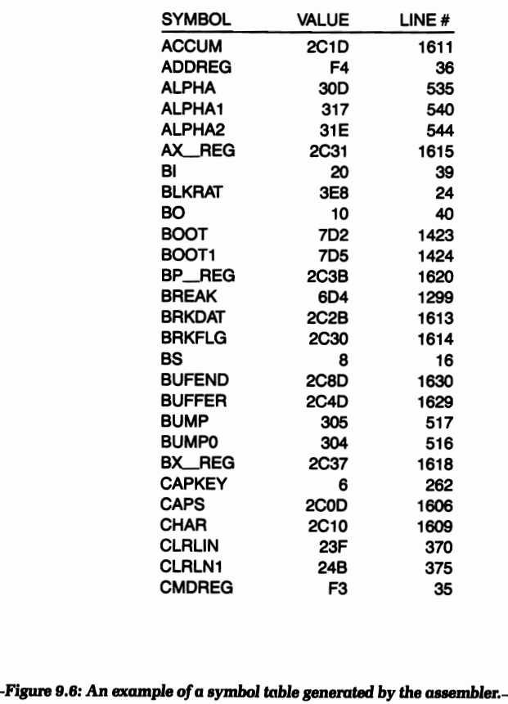

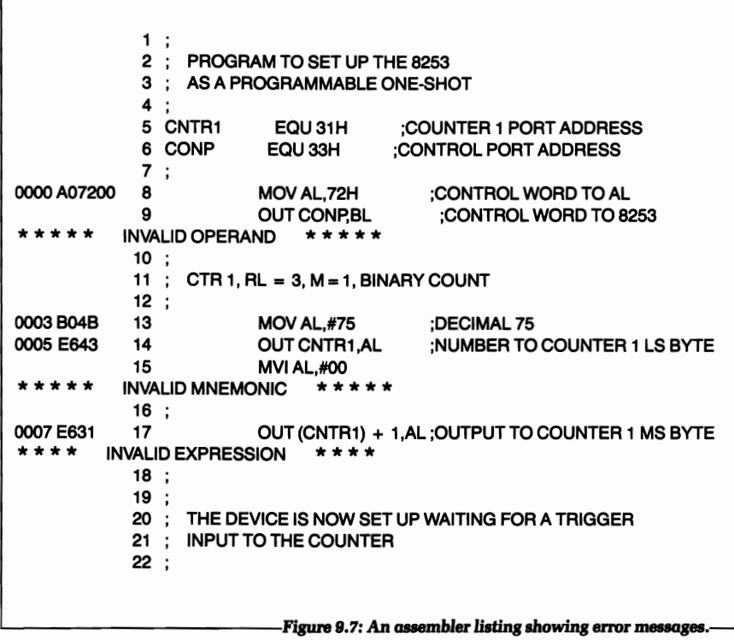







# Assembler Tutorial Notes

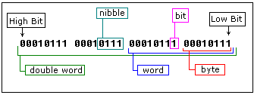

* We also add **"0"** (zero) in the beginning of hexadecimal numbers that begin with a letter (A..F), for example **0E120h**.

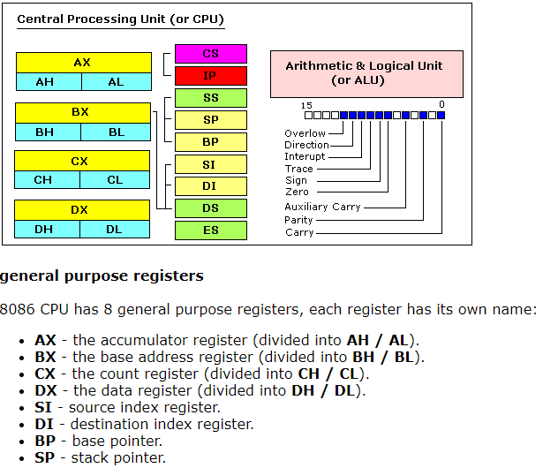

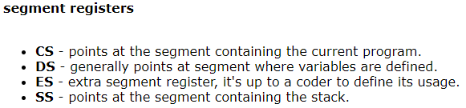

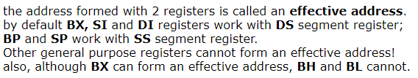

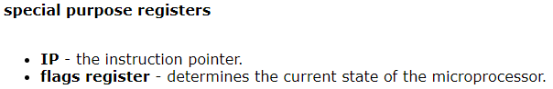

* **IP** register always works together with **CS** segment register and it points to currently executing instruction.

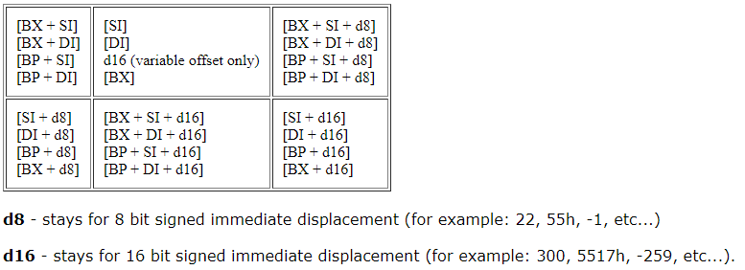

* by default **DS** segment register is used for all modes except those with **BP** register, for these **SS** segment register is used.

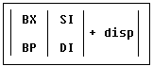

* the value in segment register (CS, DS, SS, ES) is called a **segment**,  
  and the value in purpose register (BX, SI, DI, BP) is called an **offset**.  
  When DS contains value **1234h** and SI contains the value **7890h** it can be also recorded as **1234:7890**. The physical address will be 1234h * 10h + 7890h = 19BD0h.

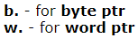

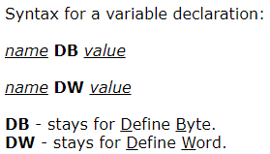

* **ORG 100h** is a compiler directive (it tells compiler how to handle the source code). This directive is very important when you work with variables. It tells compiler that the executable file will be loaded at the **offset** of 100h (256 bytes), so compiler should calculate the correct address for all variables when it replaces the variable names with their **offsets**. Directives are never converted to any real **machine code**.

### getting the address of a variable

* Please note that only these registers can be used inside square brackets (as memory pointers): **BX, SI, DI, BP**!

### Constants

* EQU

## Interrupts

* INT value
* 0 to 255 + sub-functions (65536 functions over all)

-> lab exercise 7

# Random

## Control Unit:

* Talks with memory
* Talks with ALU
* Sends data to devices through motherboard

## ALU: Arithmetic-Logic Unit

* Calculations
* Flags

## Fetch – Decode – Execute:

* Data is fetched from memory
* Instructions are decoded from data
* Instructions are executed.

## Thread:

* Core has 2 threads.
* If thread 1 waits for some information, thread 2 will run and the core will no be idle. Core is a mouth and threads are hands. It is more efficient to eat with both hands than one.
* The limit is set to 2, because more would be a waste of resources.

## Cache:

* Fastest type of memory
* Multiple caches: L1, L2, L3: Memory speeds get better and sizes smaller in higher cache heararchy
* Uses SRAM (static ram): faster, more expensive
* Cache is middle man between CPU and RAM

## Enable wire:

* Retrieve data from memory

## Set wire:

* Write data to memory

## Program Conter (or instruction address counter):

* Where we are in a program

## The Clock:

* Tempo of CPU
* Clock Speed:
* The speed which a CPU can carry out each step of the fetch-decode-execute cycle
* Measured in Hertz
* Overclocking: speed up the clock speed. The CPU might overheat or the signals fall behind
* Underclocking: can save a lot of power
* Moder processors can increase or decrease the clock speed, based on demand: it is called dynamic frequency scaling

## Register:

* A quick place to store data for further use

## Intel cpus:

* P-core: Performance-cores: Foreground: Optimized for handling single and lightly-htreaded performance. Enhanhcing gaming and productivity workload
* E-core: Efficient-cores: Optimized for handling scaling hightly-threaded workloads. Minimizing interruptions from background task management.

# 3

5.7

* <https://www.makeuseof.com/tag/what-is-cpu-cache/>
* Cache
* <https://quedeus.com/en/how-a-cpu-works/>
* Control Unit
* ALU
* Enable wire
* Set wire
* Program conter
* 32 bit and 64 bit
* <https://en.wikipedia.org/wiki/Processor_register>
* Register